**WS32 - GROUPS**

**DATE: 03th february 2021**

**TEAM 1:**

Salma Villegas

Alexander Ruano

Daniel Lincango

Mateo Maldonado

Leandro Quinga

Joel Zeas

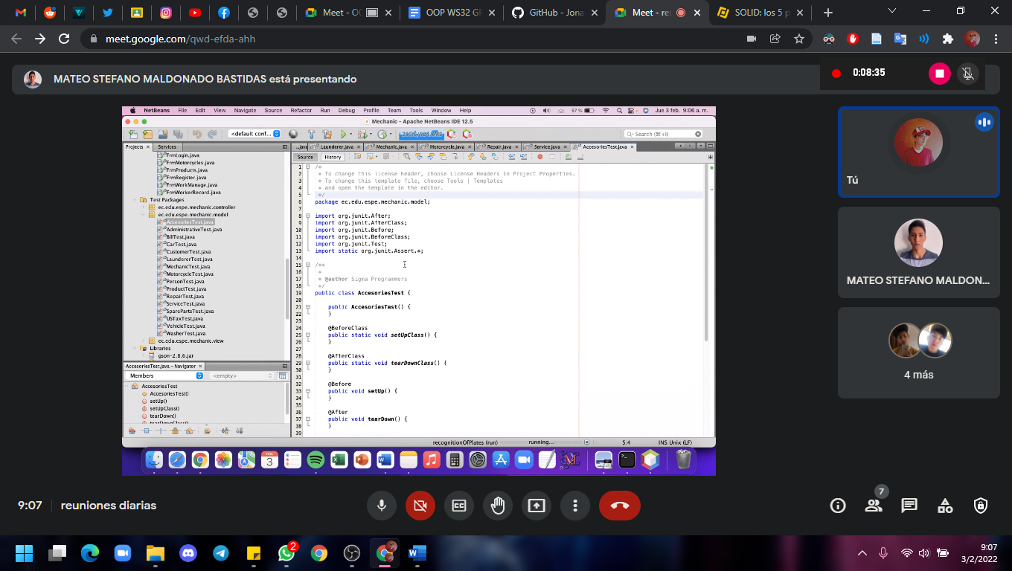

Innecesary comments, unclean code

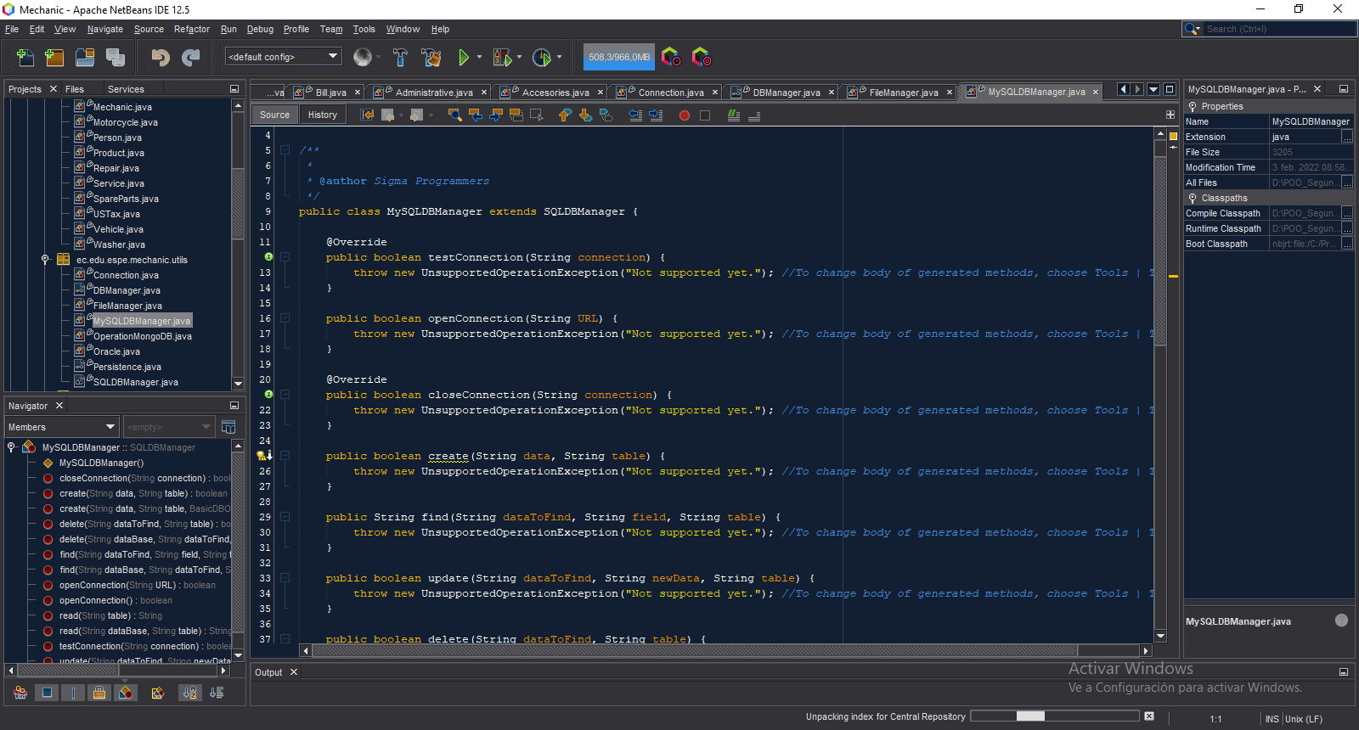

Unclean Code

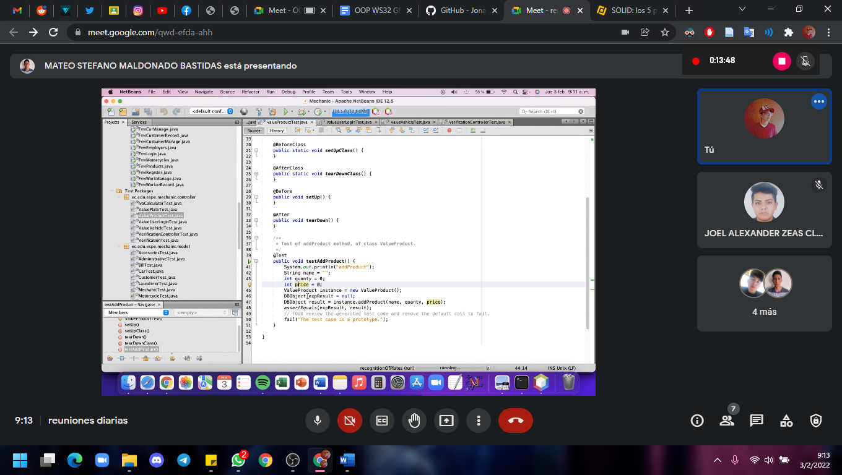

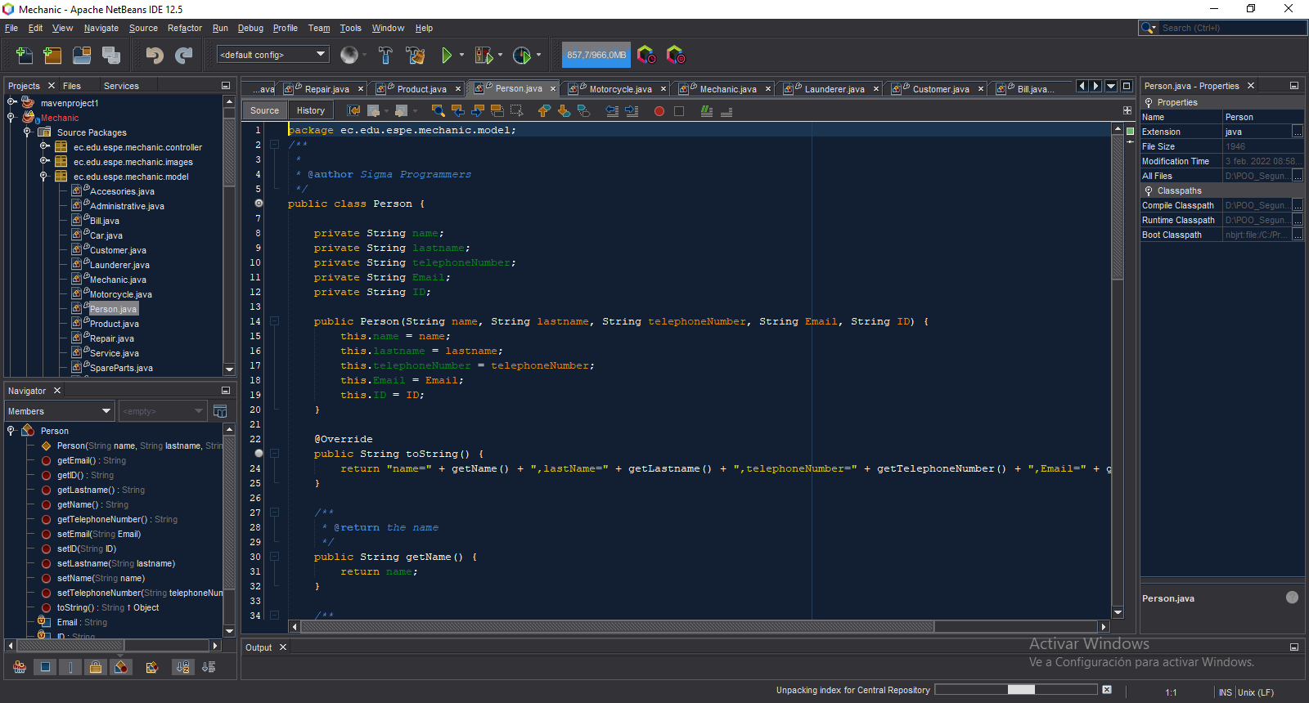

do not use the format Camelcase

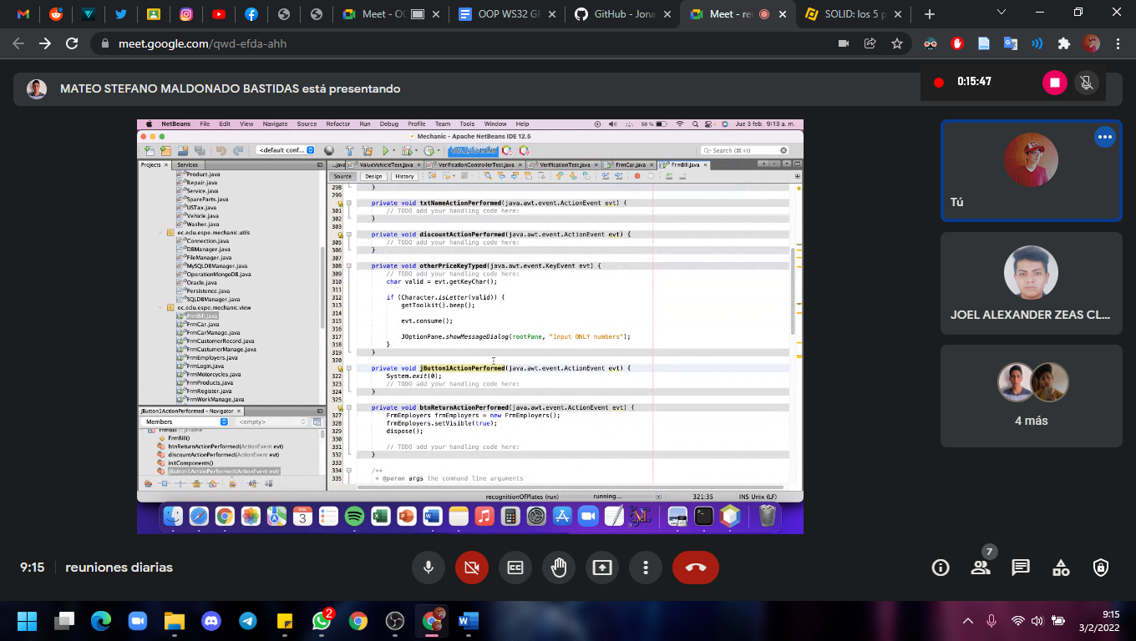

Refactor jbutton

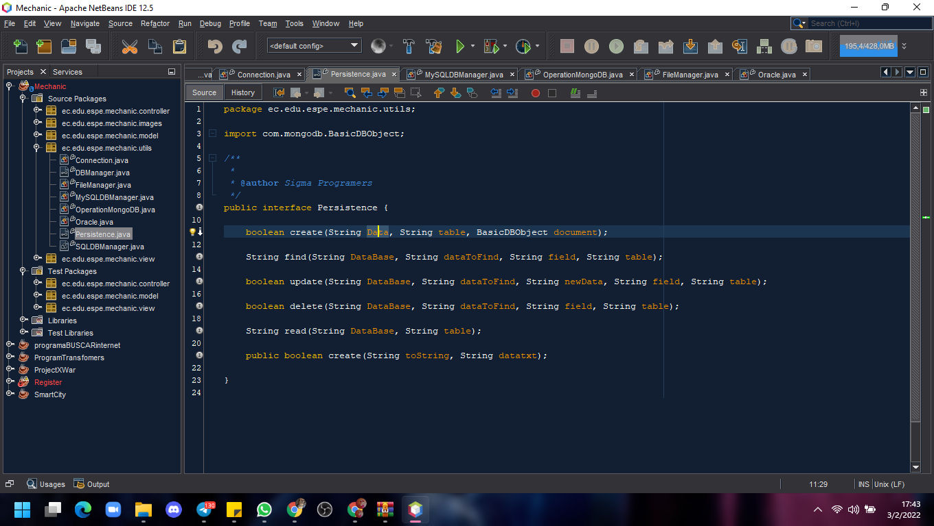

Don't use camelcase

- Very redundant class names, difficult to differentiate

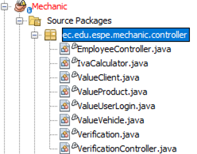

* **Single ResponsibilityPrinciples:** there is no relationship between the “document” variable and the “addVehicle” class. It is also a very general term.

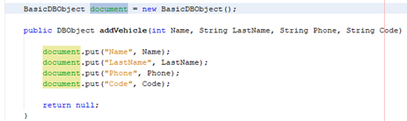

- Use an else variable that replaces the return and returns an actual data

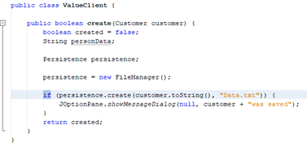

- Use lower case for variables



- Getters and setters must be programmed in the “.model” package, no in the “.controller” package

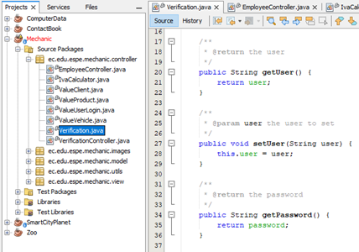

- **Open/Closed Principle:** Very general variable and method names, also the user validation programming is usually done in the .view package and it must be open to extend it

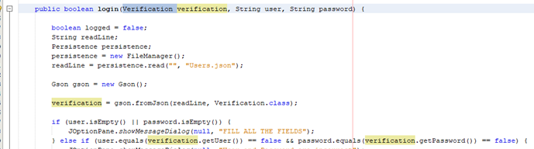

**Source Packages**

**Package:** ec.edu.espe.mechanic.images

Nothing to mention, each class has only one image.

**Used Principles:** Single Responsibility Principle (each class have only one image)

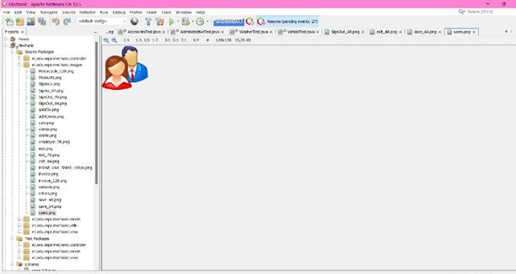

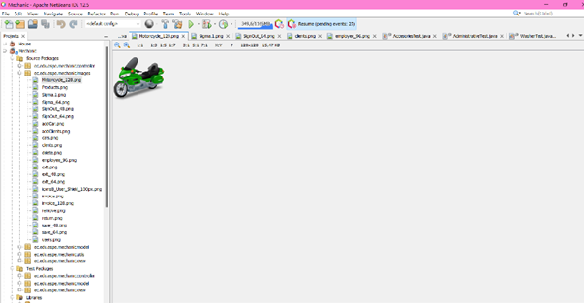

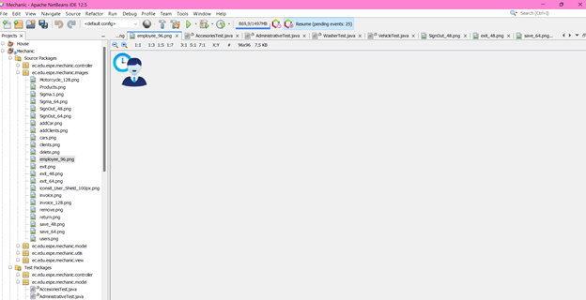

**Test Packages**

**Package:** ec.edu.espe.mechanic.model

Unnecessary comments, unclean code,

**Used Principles:** Single Responsibility Principle (This package is being used for testing only, so each class has a unique reason)

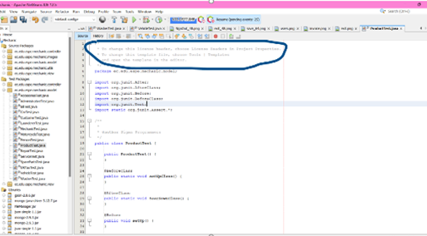

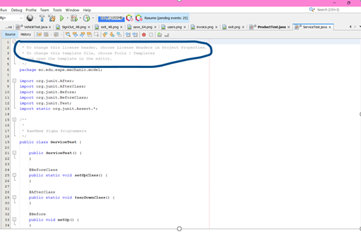

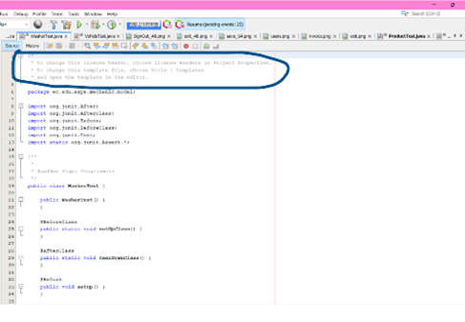

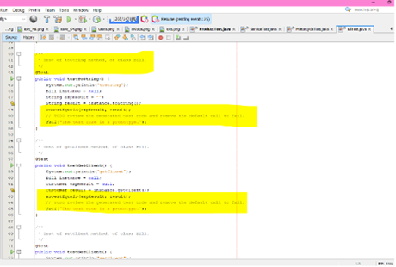

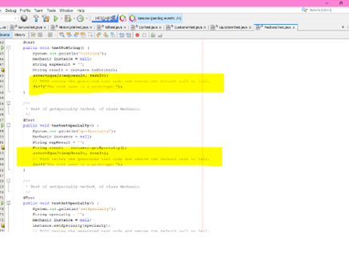

**TEAM 2:**

Mateo Landazuri

Andy Calderon

Leonel Mantuano

Pablo Bustillos

Richar Maisincho

Sebastian Palacios

* Attributes in different sizes are written with camelcases

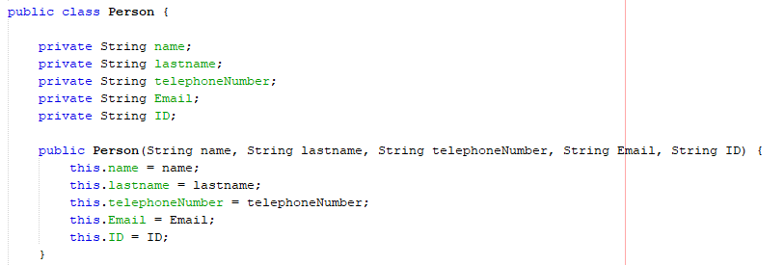

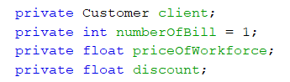

* Unnecessary comments

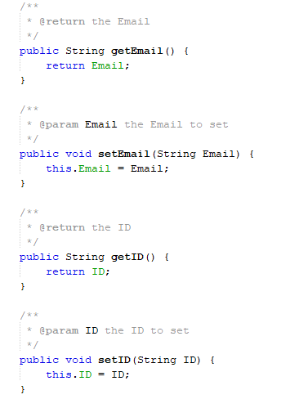

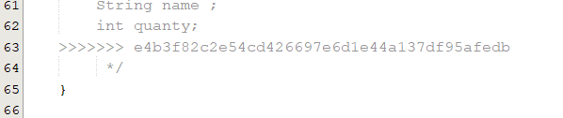

* Comments not deleted

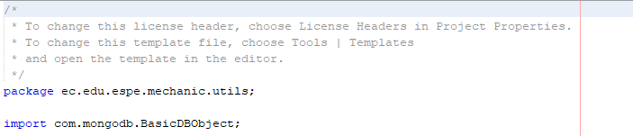

* Don’t change variable names

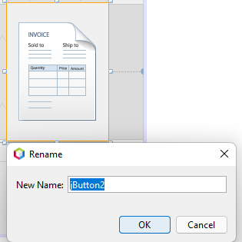

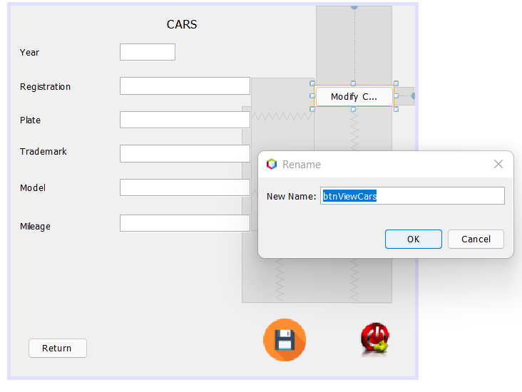

* Capital letters are not used

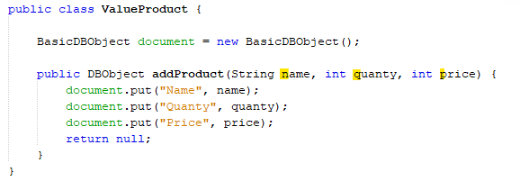

* Class names must be singular nouns

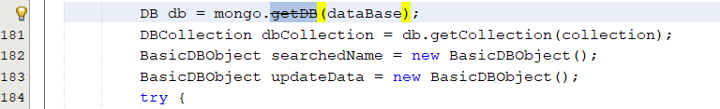

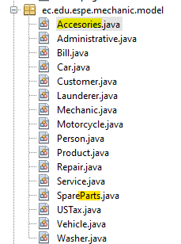

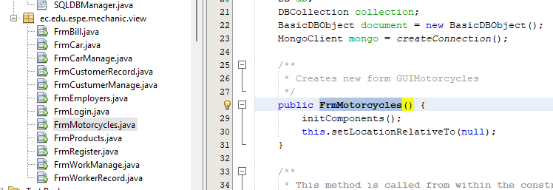

-**Single responsibility** (The connection to the database must be made by a single class, not two.)

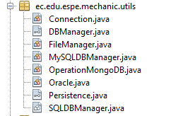

**-Open / Closed Principe**

Change the name of the array related to the project and the records it manages

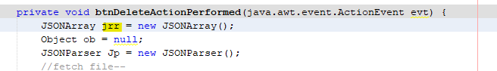

* The graphical view interface has 3 additional buttons that do not explain the operation (methods declared without using).

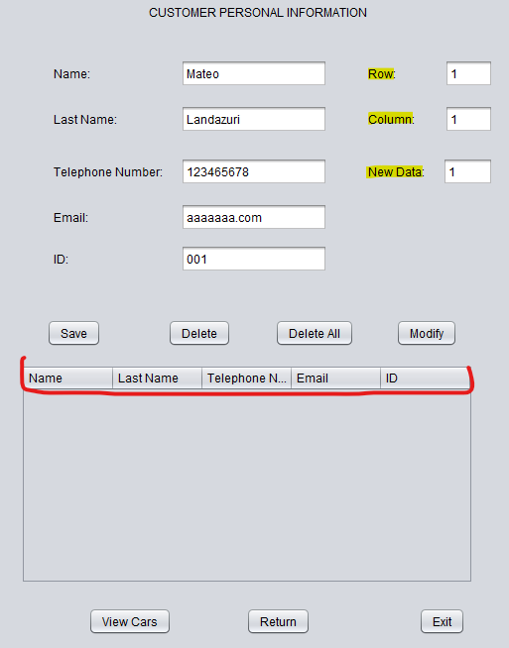

**TEAM 3:**

Paul Saltos

Javier Paucar

Cristian Arroba

Melissa Gómez

José Guzmán

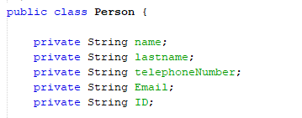

-variables must be written with lowercase

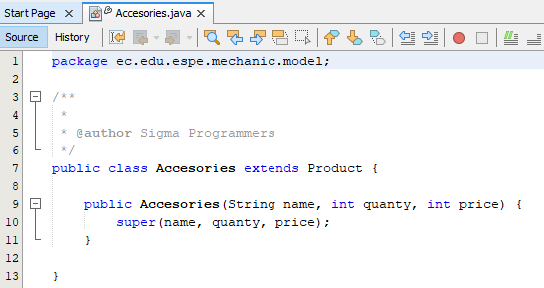

* Classes must be singular

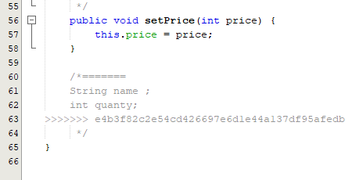

* uncommented code

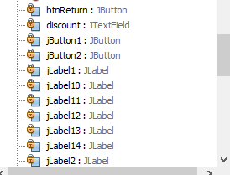

**-**Must have specific names

**Single responsibility:** The user or client must know the data to be added

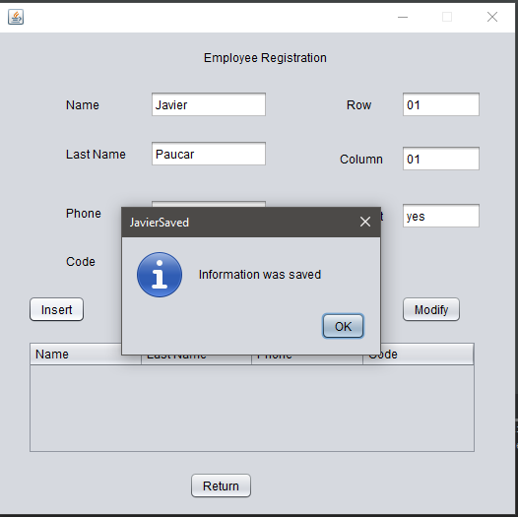

**Interface segregation:**

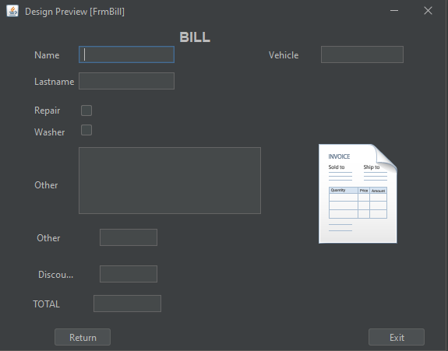

**TEAM 4:**

Angel Guaman

Sebastián Caisatoa

Sebastián Tayo

Antony Morales

José Sánchez

**Open closed principle**

Declaration of variable

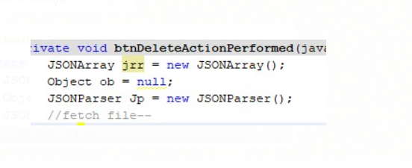

The second variable starts with mayus, and not in lower Camel case.

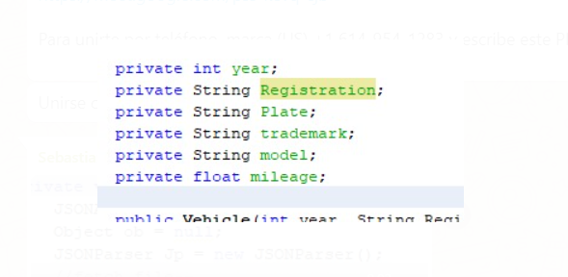

Unnecessary comments

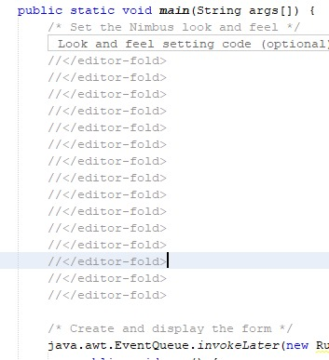

Unprogrammed code

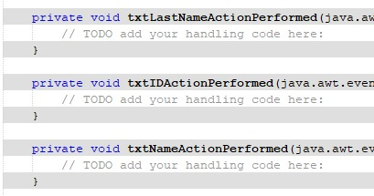

It calls the mongo db Connection in a button.

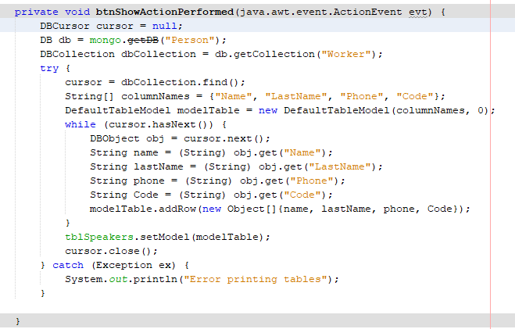

**Interface segregation principle**

table don’t have information of form

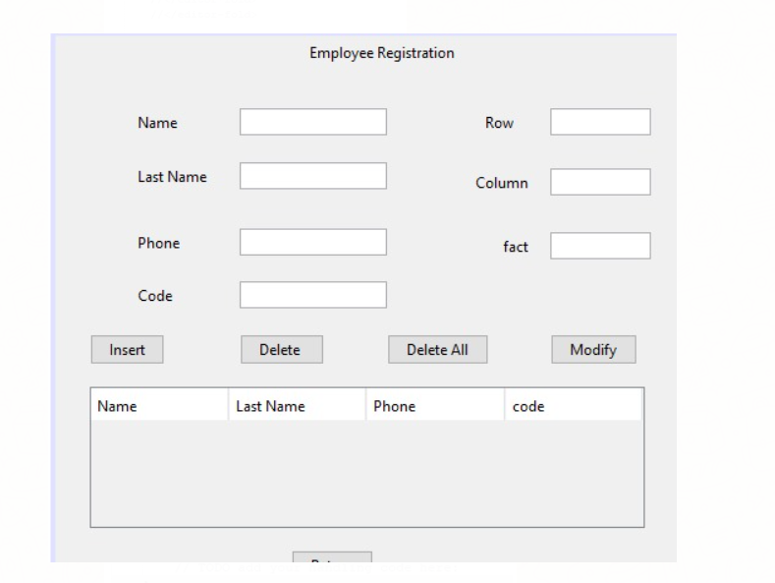

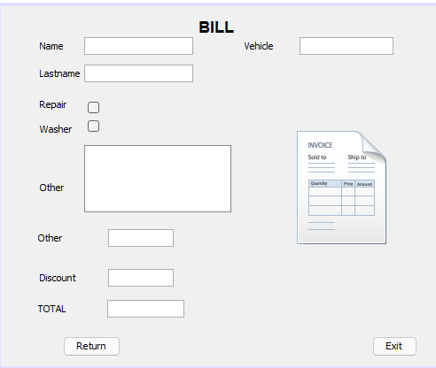

**Single Responsibility**

Only one class in the utils package, no more than two

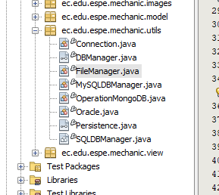

**Undeclared Buttons**

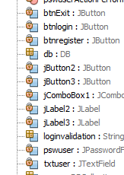

**Segregation principle**

Program clients must know what data is entered and what methods are actually to be used

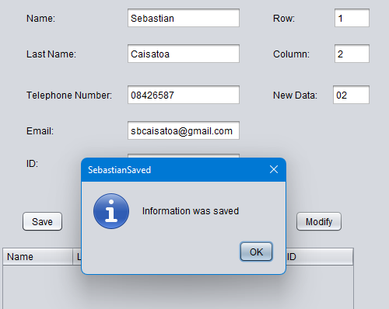

**TEAM 5:**

Alvarez Michelle

Correa Kerly

Eivar Jaime

Garcia Mayerly

Teca Camila

Teran Melanie

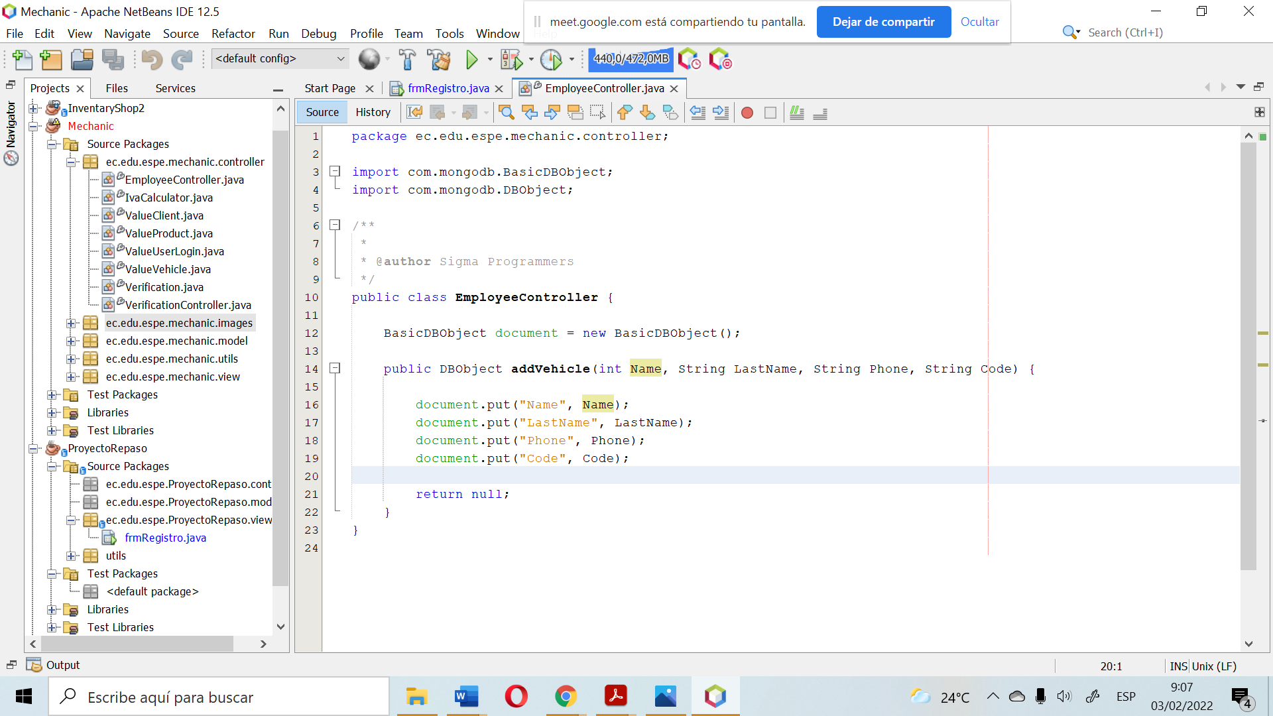

The name is declared as a int, it should be String - Bad quality code

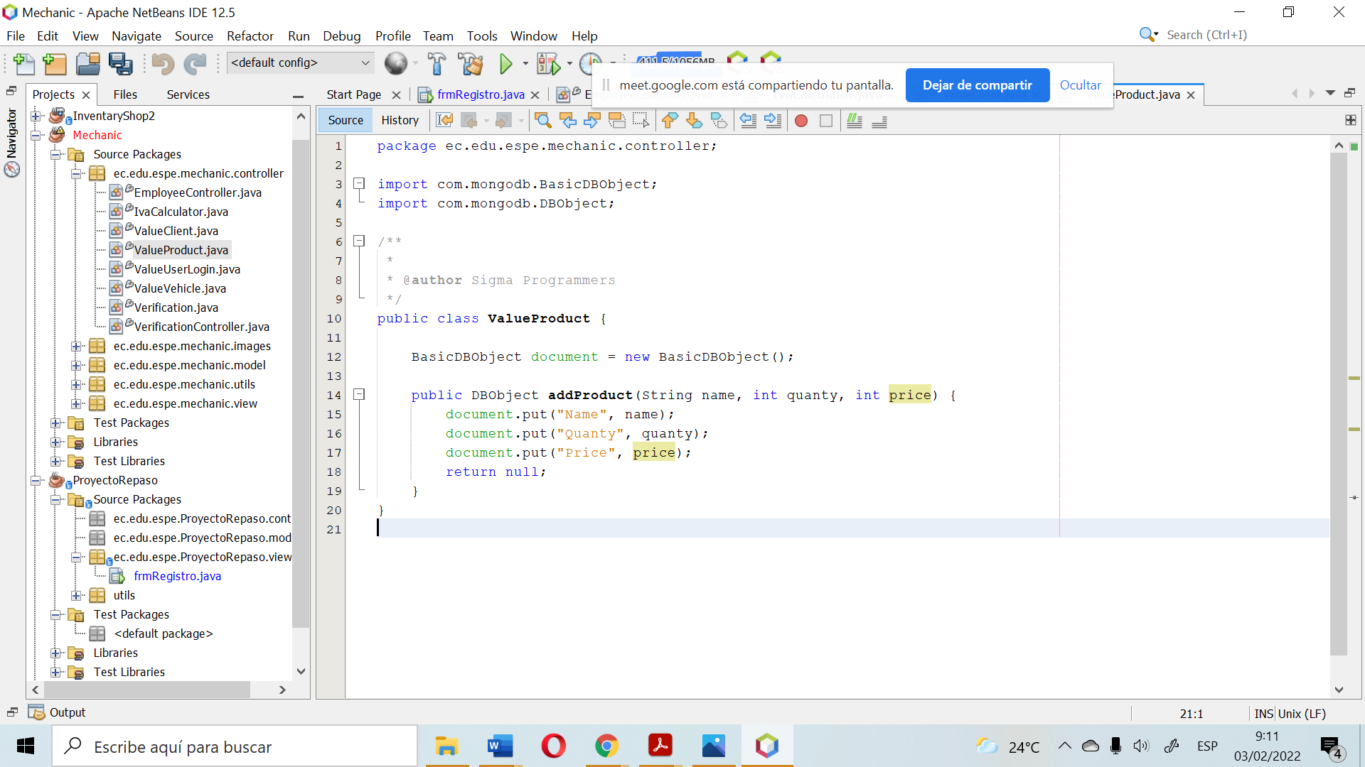

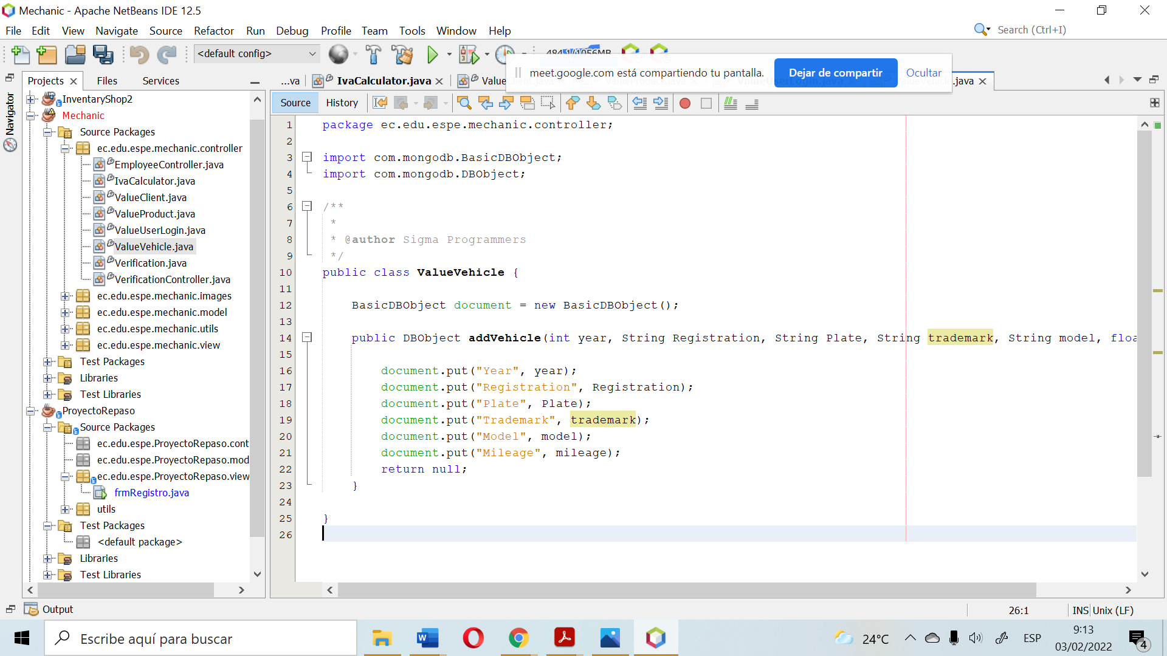

Incorrect class names. Classes are written in the singular:

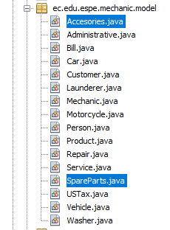

They are not names for the buttons:

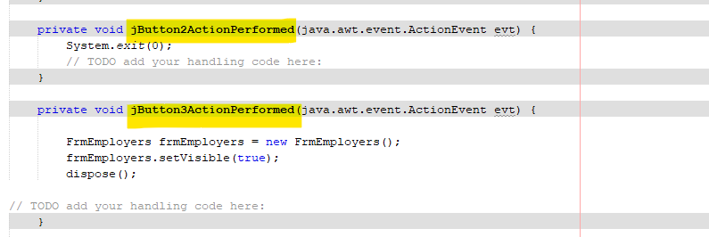

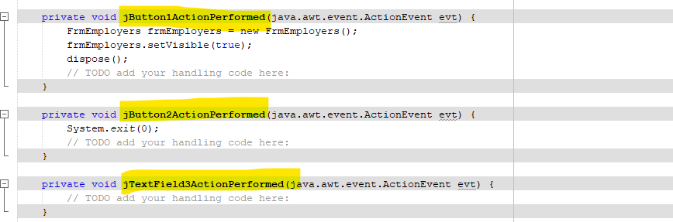

In the utils package there should be one class to the database, but no more than two classes connecting to the same database. (**Single Responsibility** )

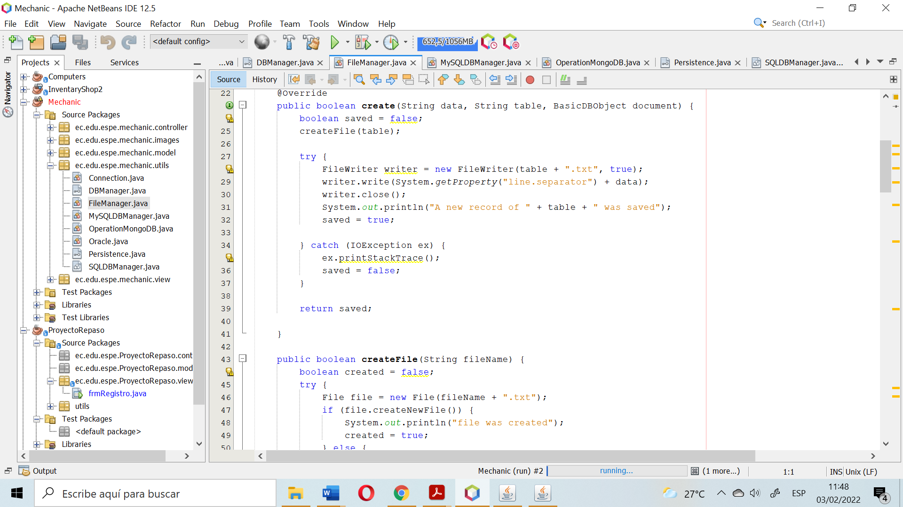

**The Interface segregation principle** is broken because the clients of the program should know what data is entered and which methods should actually be used.

Added or saved data is not displayed in the table

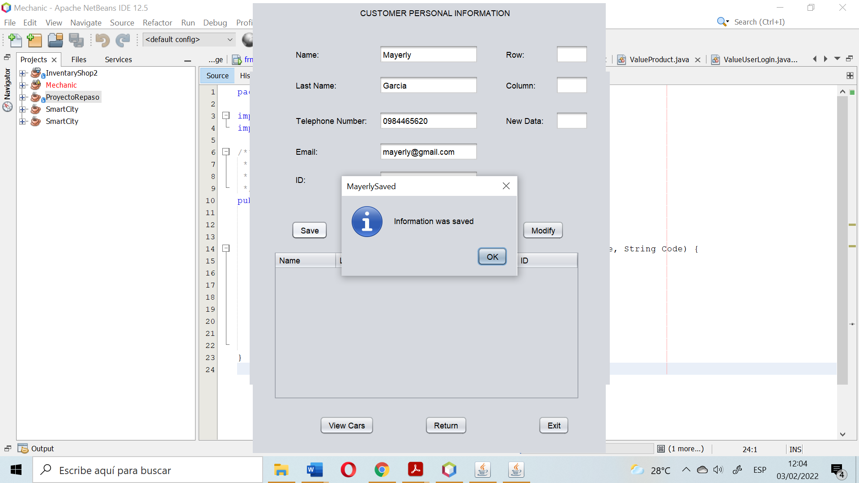

**Single Responsibility Principle** broken because has not relation with the data of the class:

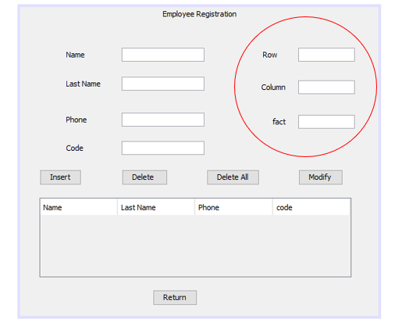

**Single Responsibility Principle** broken because the "add vehicle" object is not related to the "EmployeeController" class.

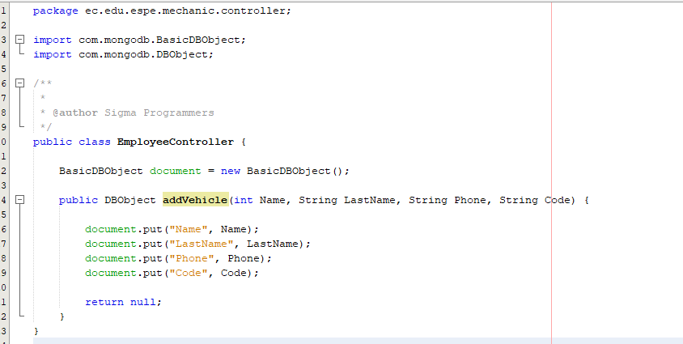

Bad declaration of the person Method of the Person class, missing to declarate id

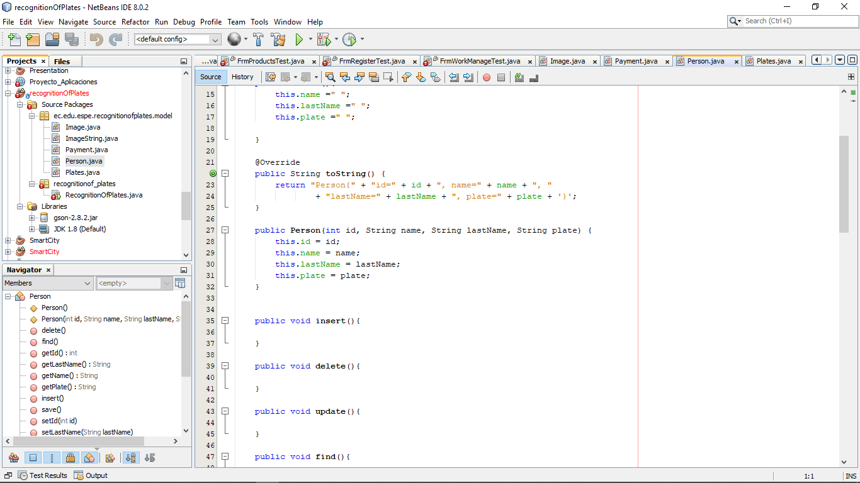

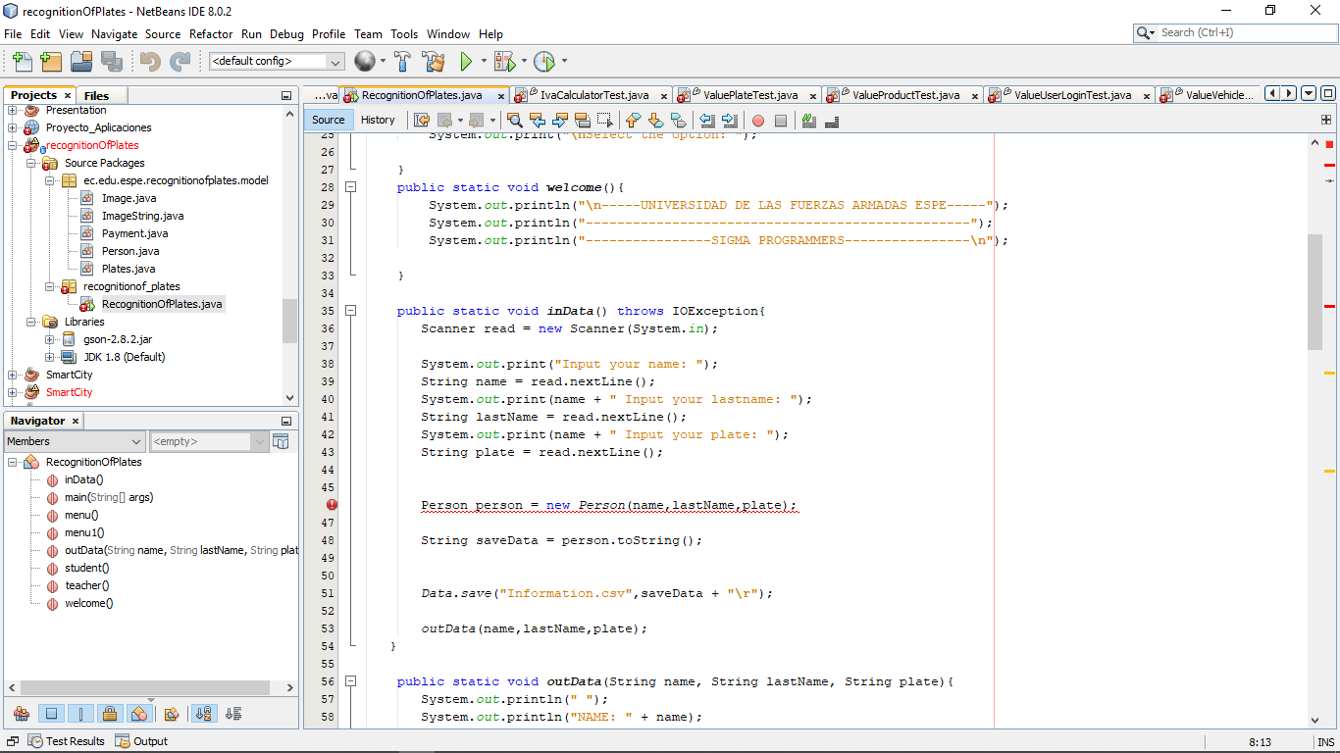

Bad names for button functions, FrmBill does not perform any function and comments not deleted

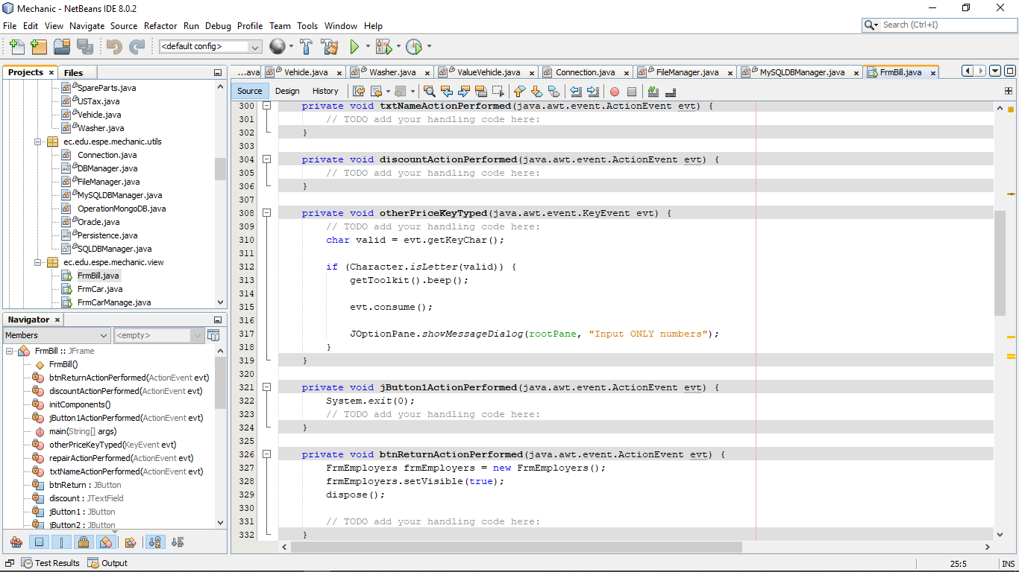

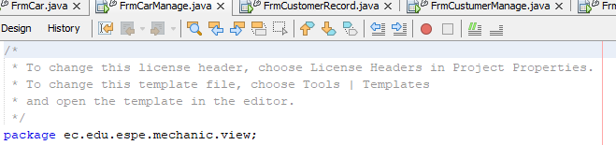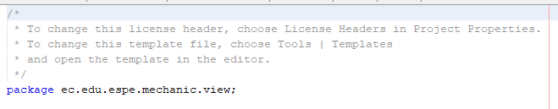

Unnecessary comments (FrmCarManage and FrmWorkManage )

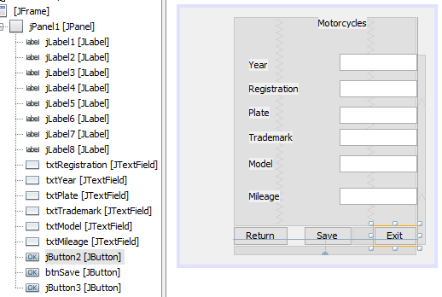

Bad names for Return and Exit buttons (FrmMotorcycles)

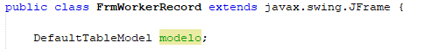

Table name in spanish (FrmWorkerRecord)

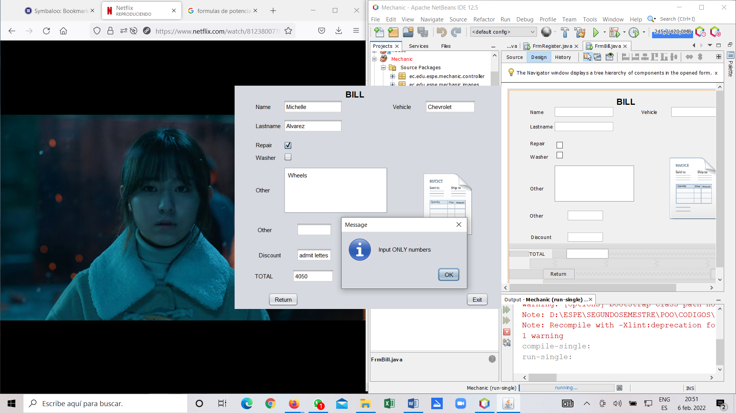

The FrmBill does not follow the **Liskov Substitution Principle** because it does not represent a window or public methods into the program. The are two fieds call “Other” and in one of them it is not clear which is the information that you have to righ. The field discount and TOTAL are not clear. They must be calculated into the program.

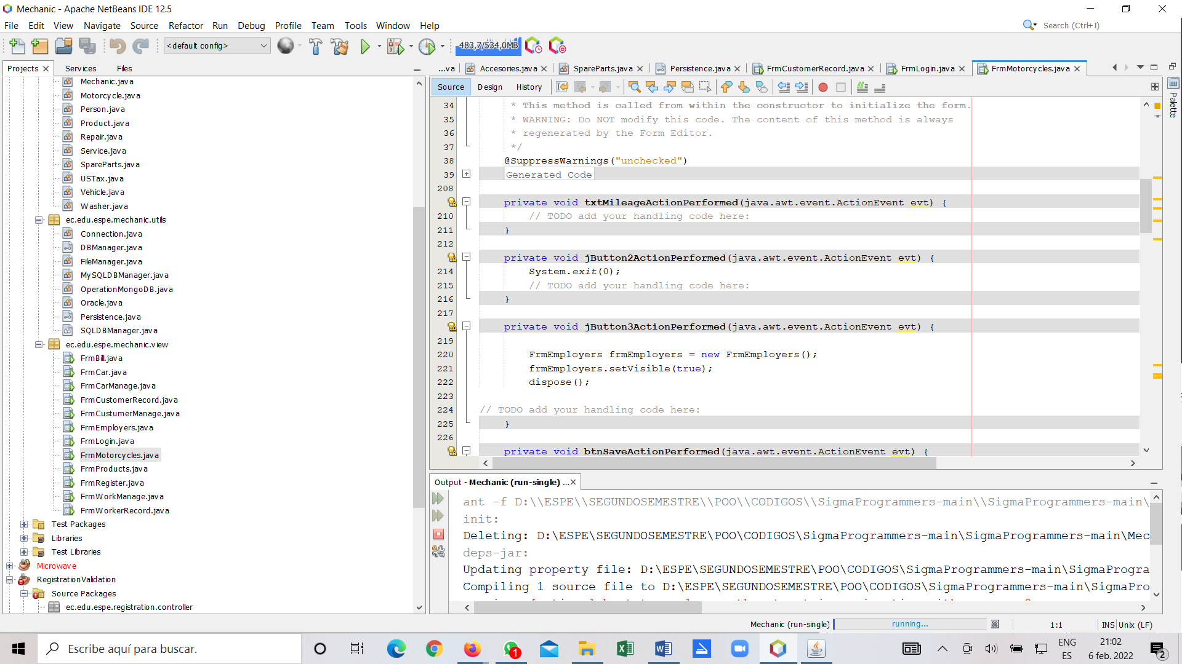

In the FrmMotorcycle the are some buttons without name so it is difficult to understand how the program works. **Unclean code.**

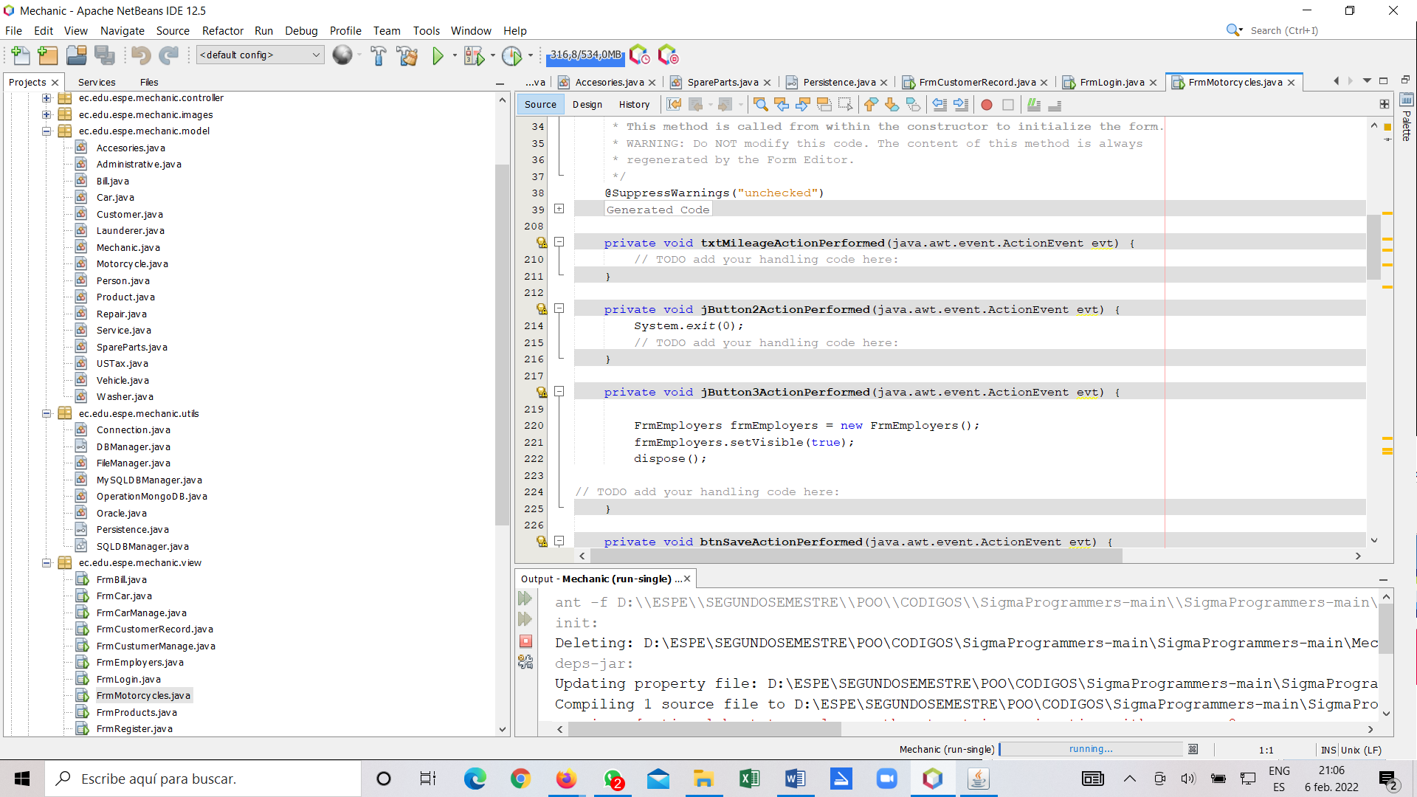

Each class should be responsible for only one part of the system's functionality. We can see there are many classes that allow the connection to the database, so it is not clear which class do a specific job. So in this part of the program does not follow the **Single Responsibility Principle.**

**TEAM 6:**

Alex Andrango

Anderson Almache

Dylan Asumaza

Cristhian Altamirano

Andrea Tapia

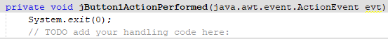Change button variable name Exit

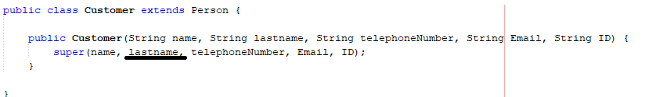Cammel Case

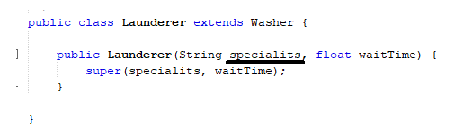

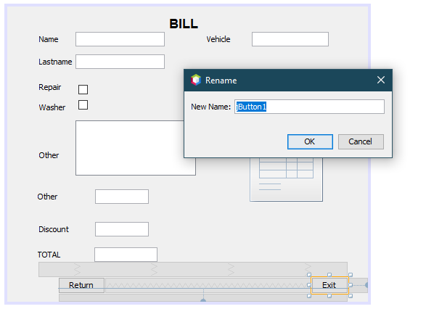

Name of the buttons

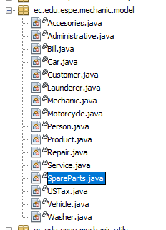some classes are written in plural

Default comments are not deleted

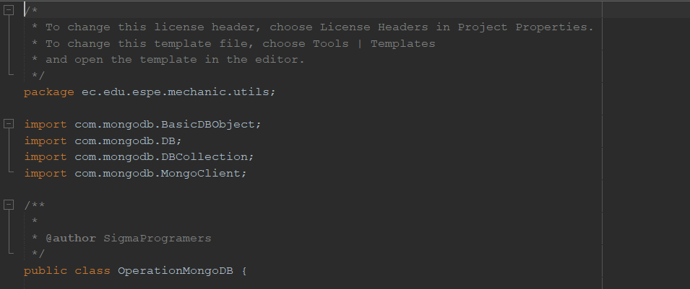

**TEAM 7:**

Alan Andrade

Katherin Bravo

Darling Cruz

Jhon Guitarra

Alejandro de la Cruz

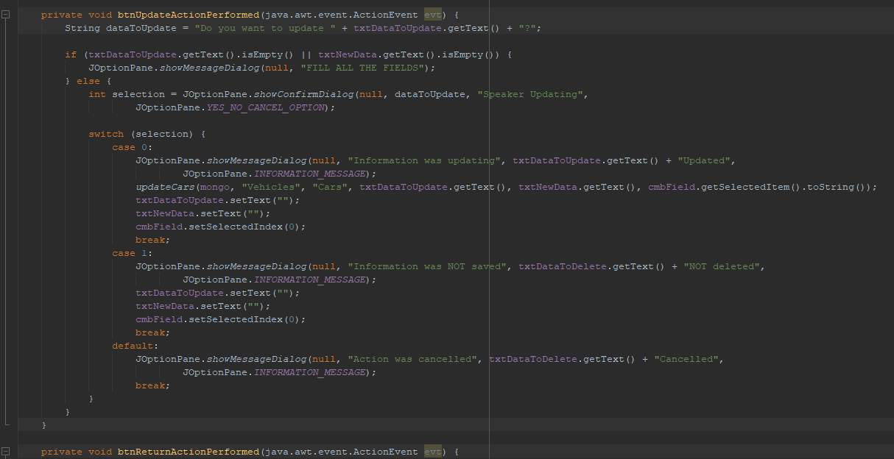

the button contains code

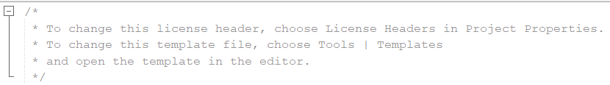

* The connection to the database is made by 2 classes when it should only have one

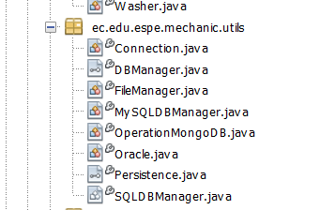

* Comments that are not necessary

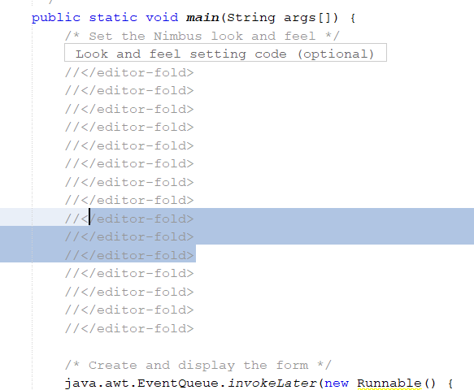

We must take into account the programming of the packages and know where each one is programmed.

The "getters" and "setters" must be programmed in the "model" package, not in the "controller" package, that's a big mistake.

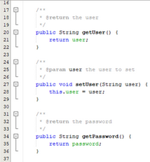

We must take into account the use of lowercase letters for the variables, since if we use uppercase letters we make a mistake.

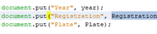

*Open/Closed*

The names of the methods and variables are very general and are not specific.

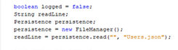

Team 8

Jonathan Insuasti

QUIZZES about SOLID Principles

ANSWERS:

1. **O**pen /closed principle (Open/close)

2. **L**iskov Substitution

3. **I**nterface Segregation

4. **D**ependency Inversion

5. **S**ingle Responsibility

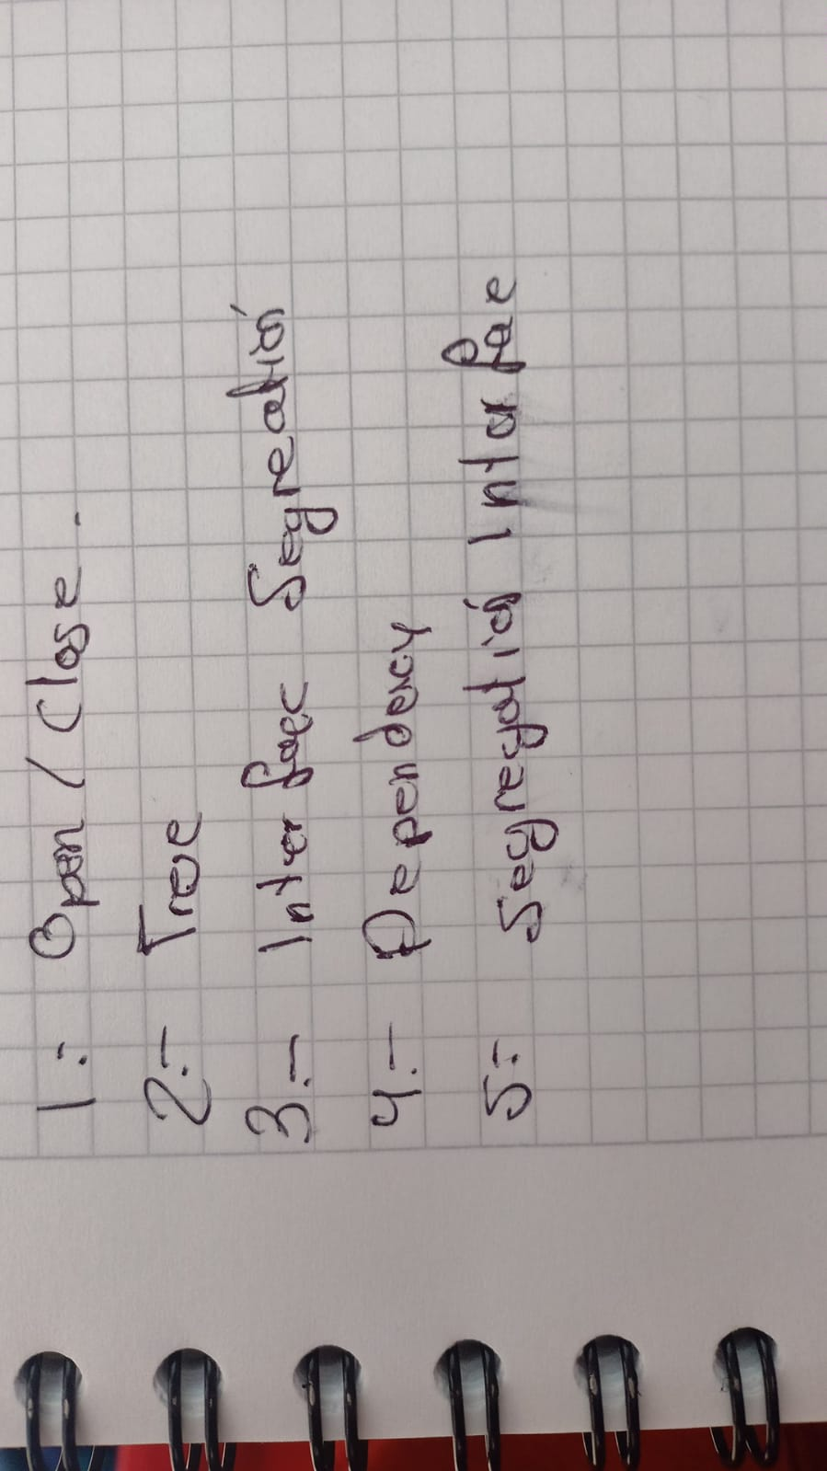

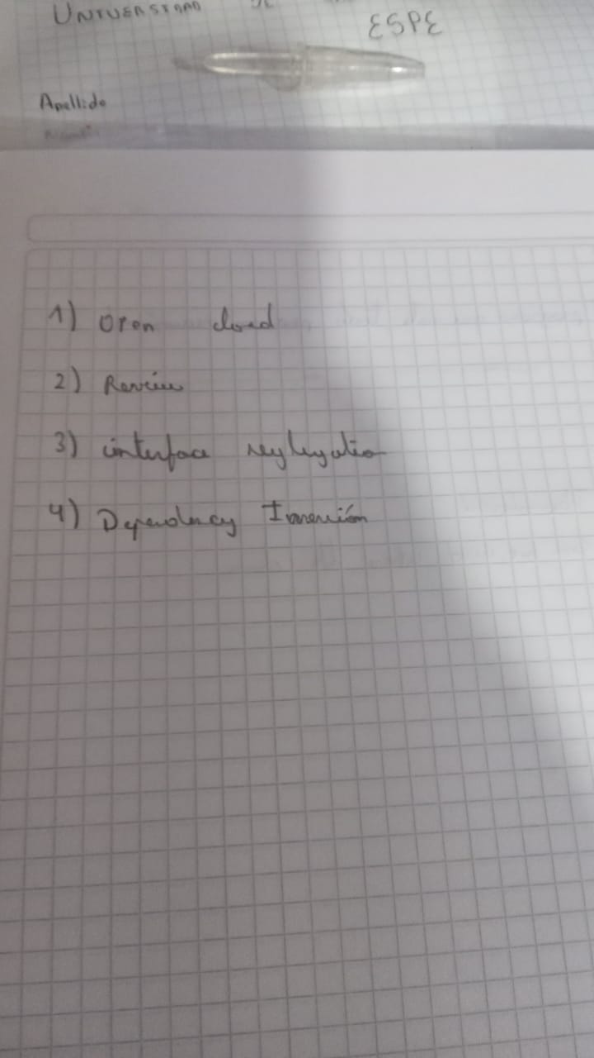

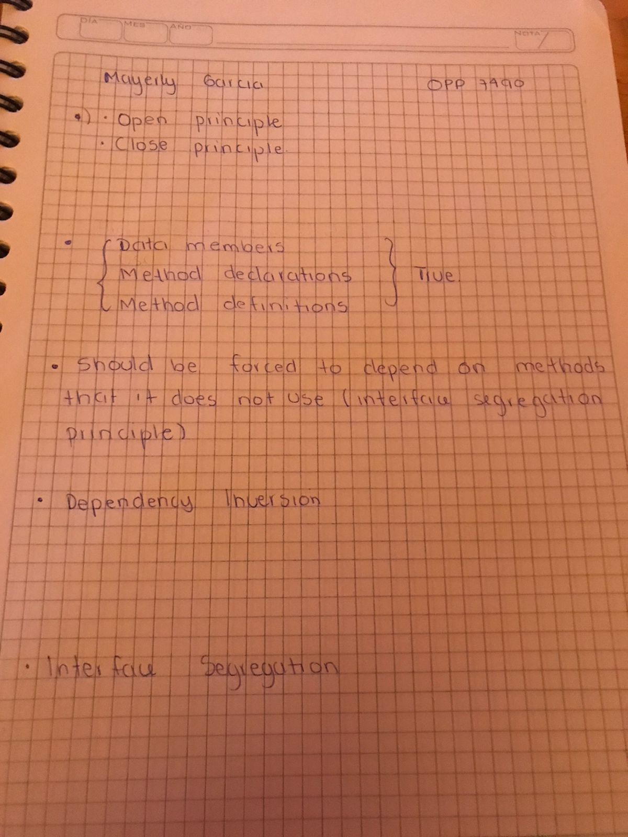

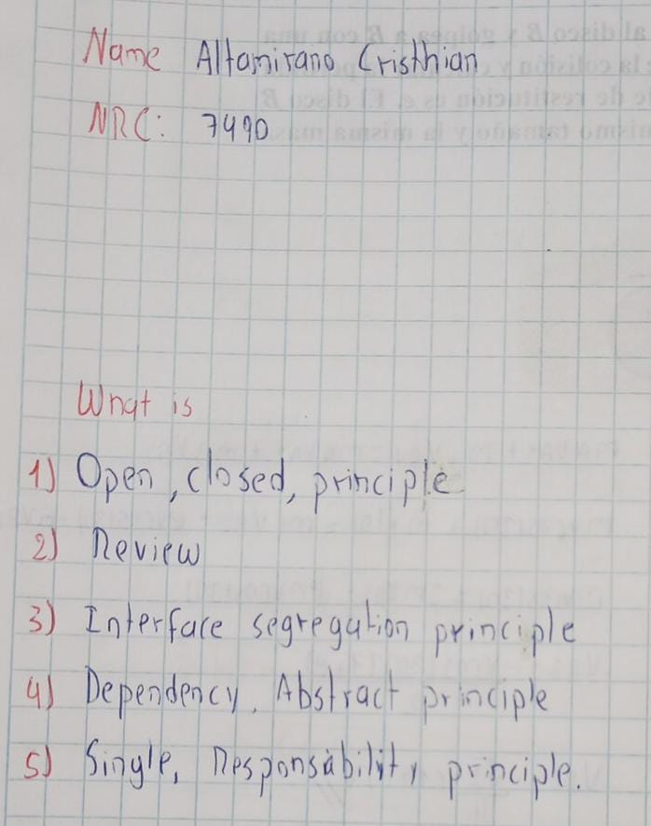

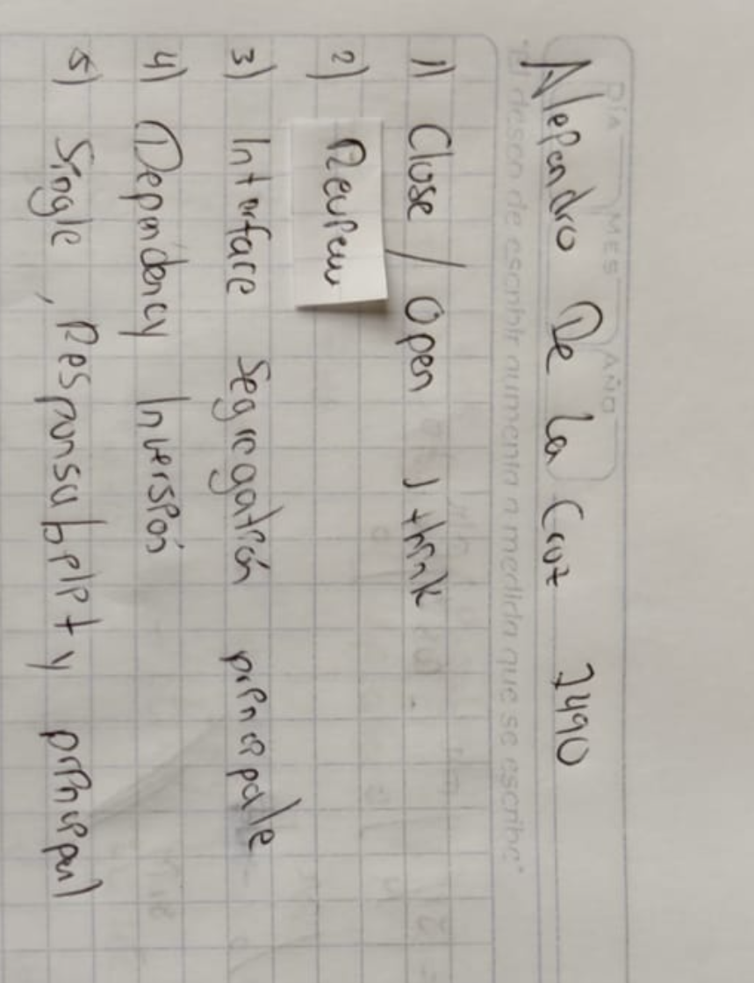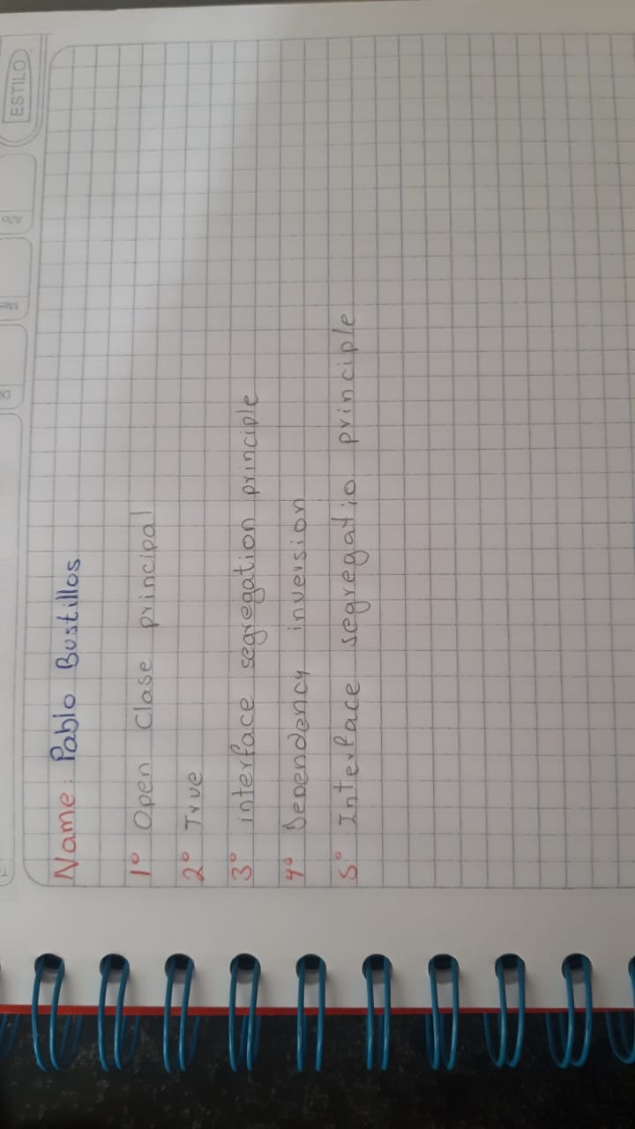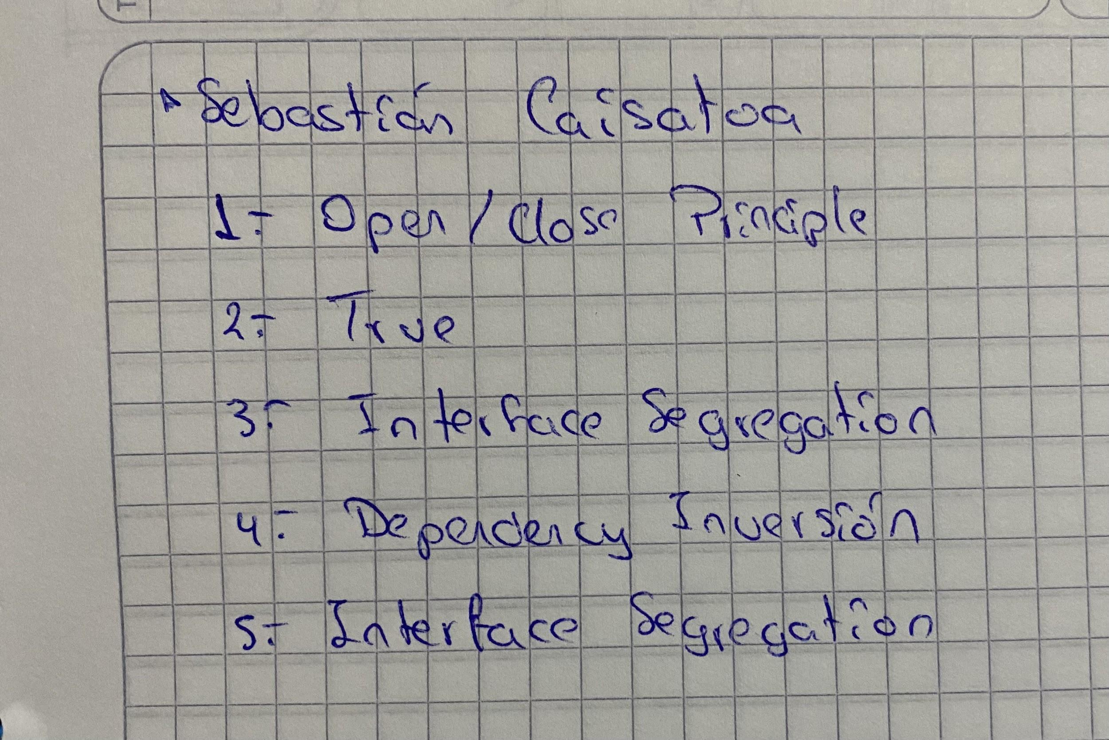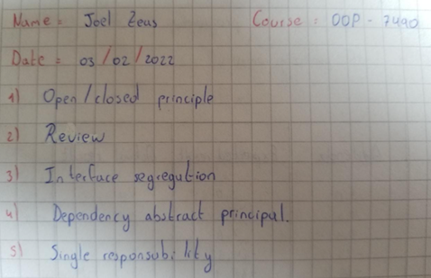

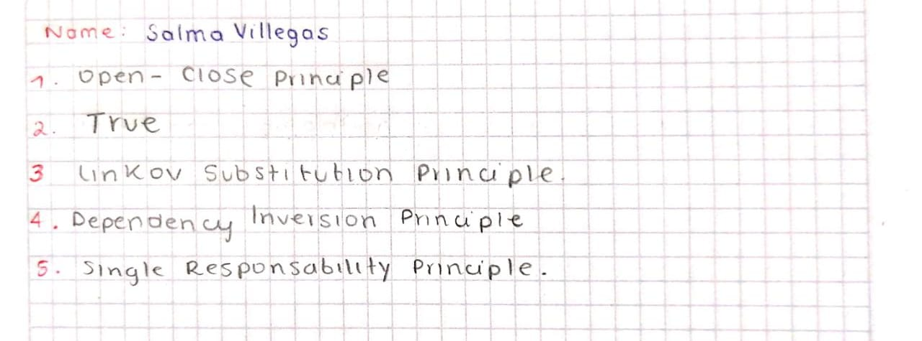

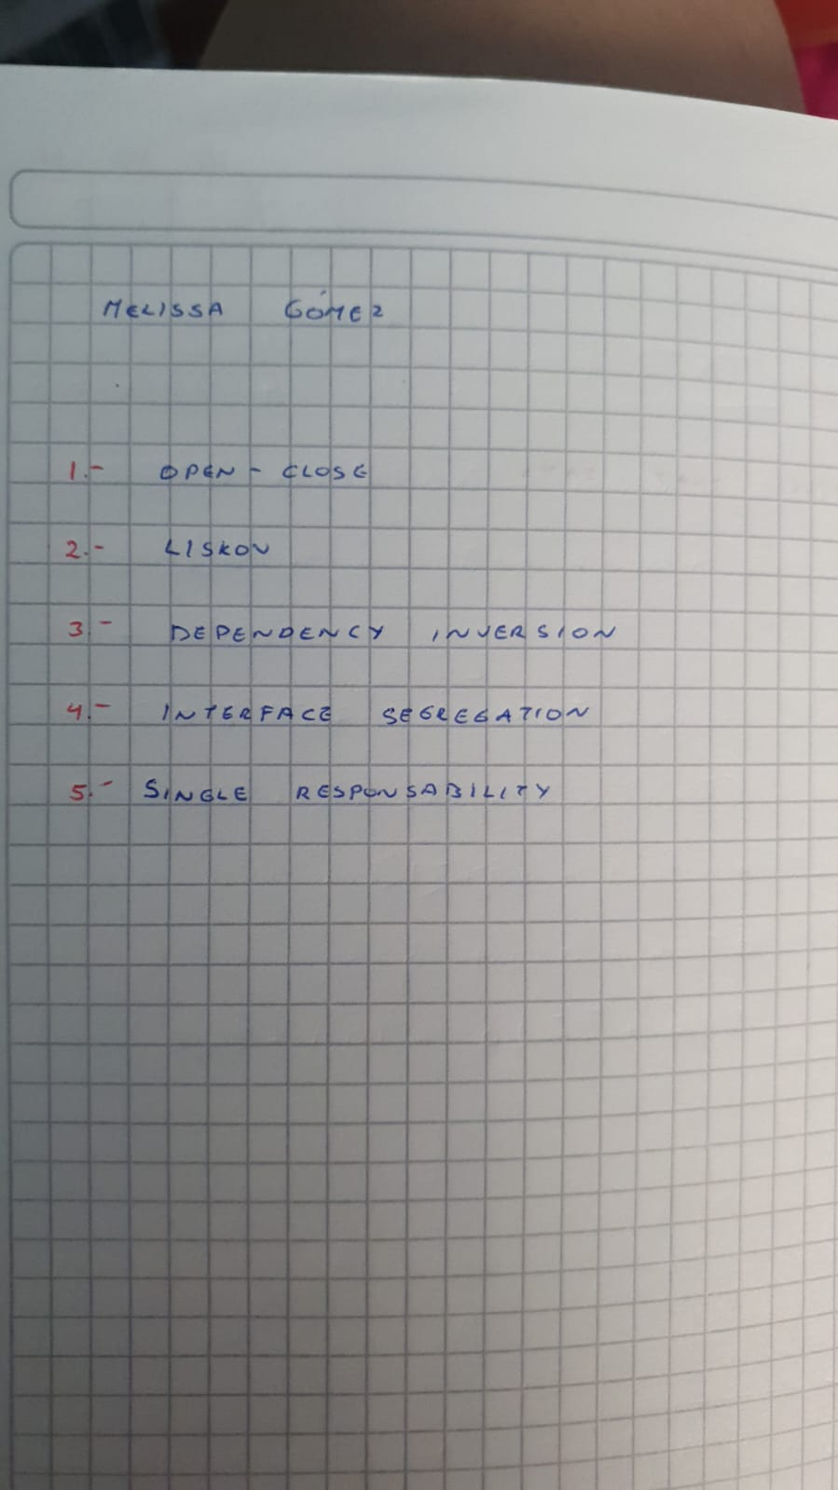

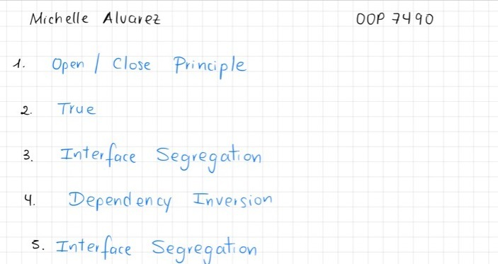

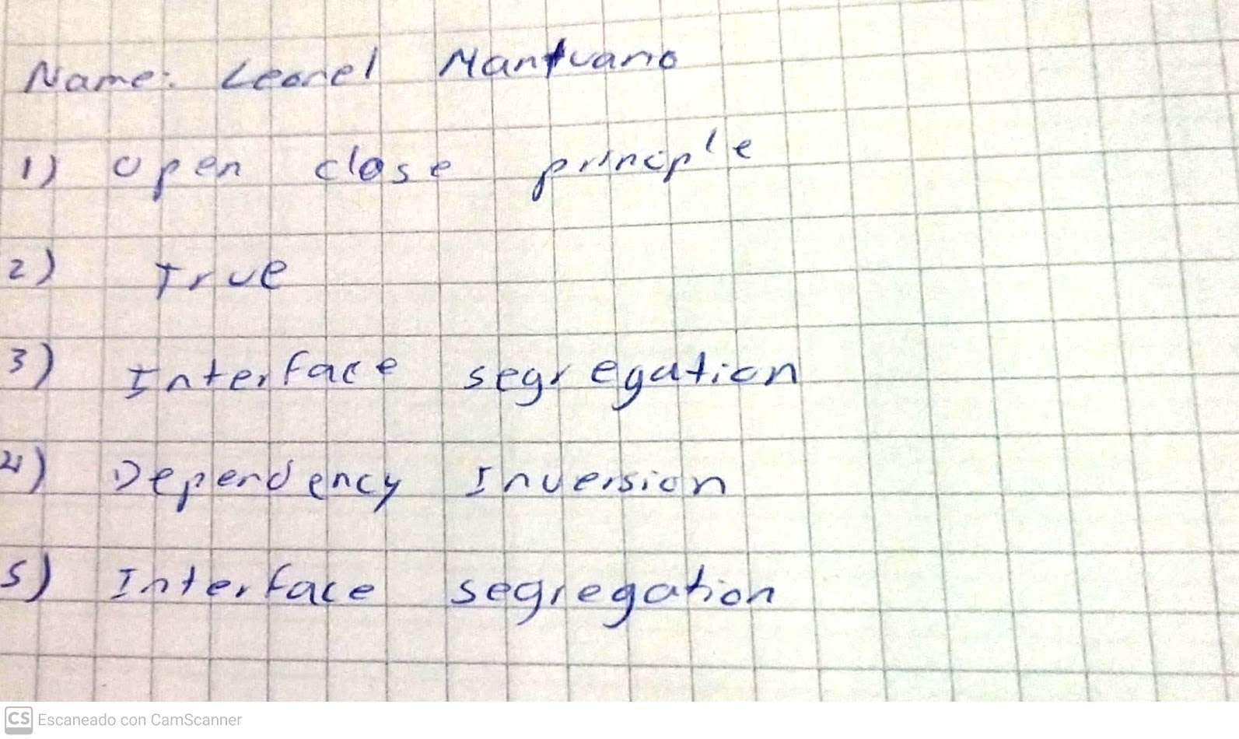

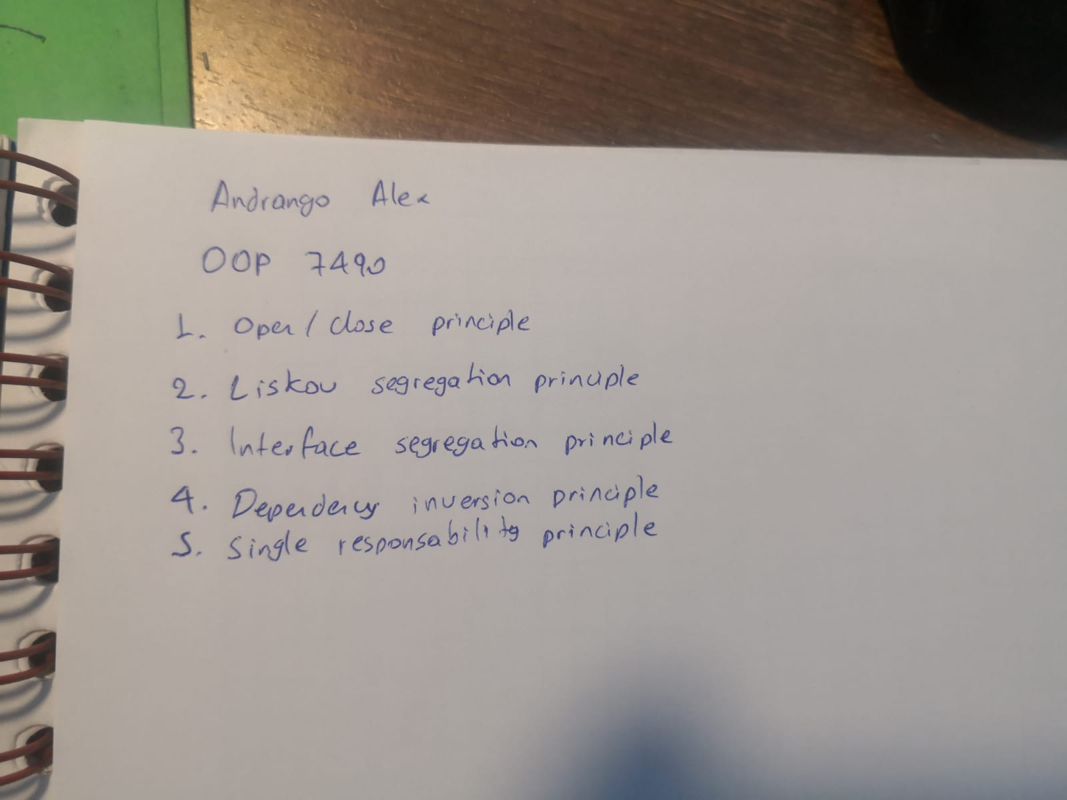

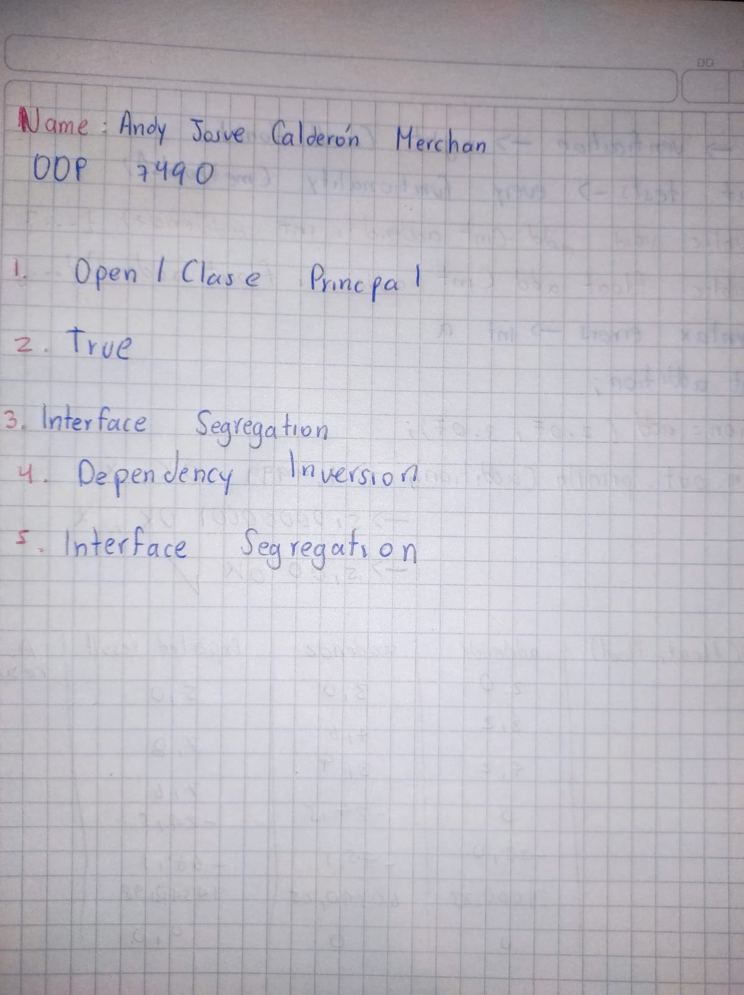

Katherin Bravo

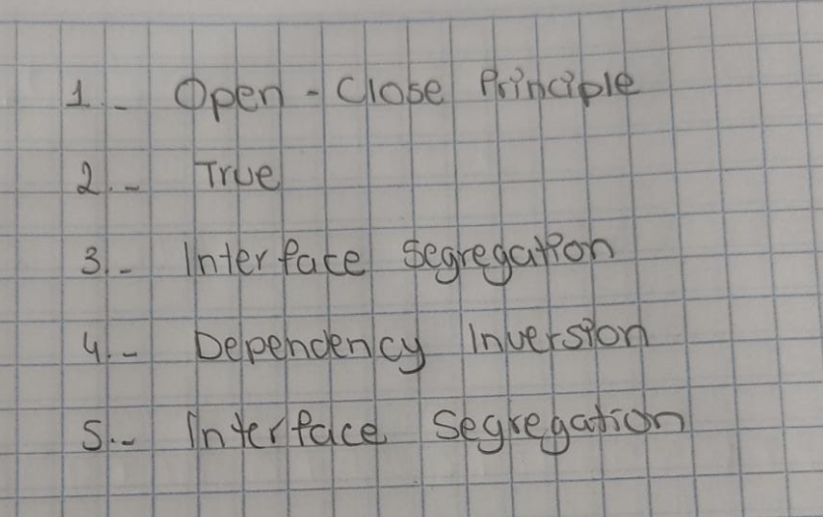

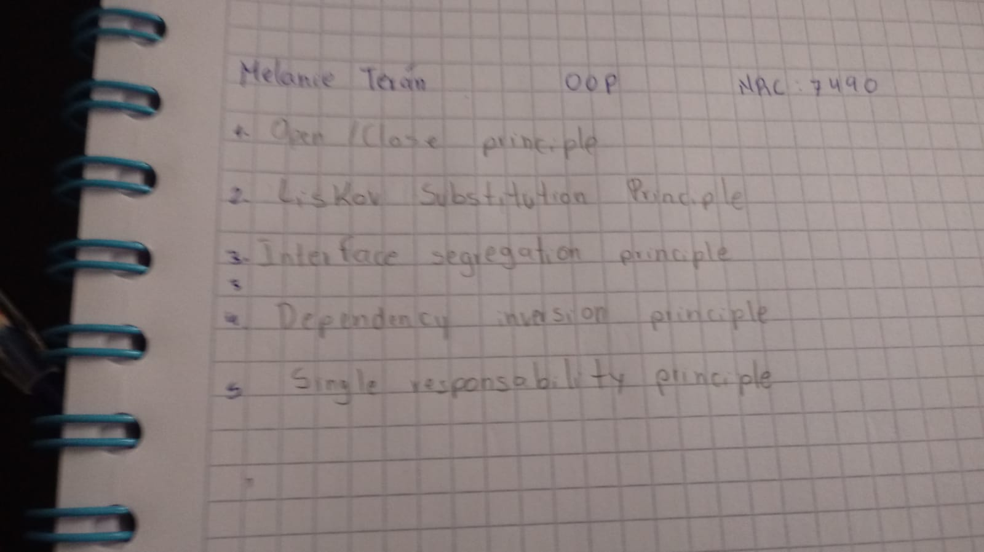

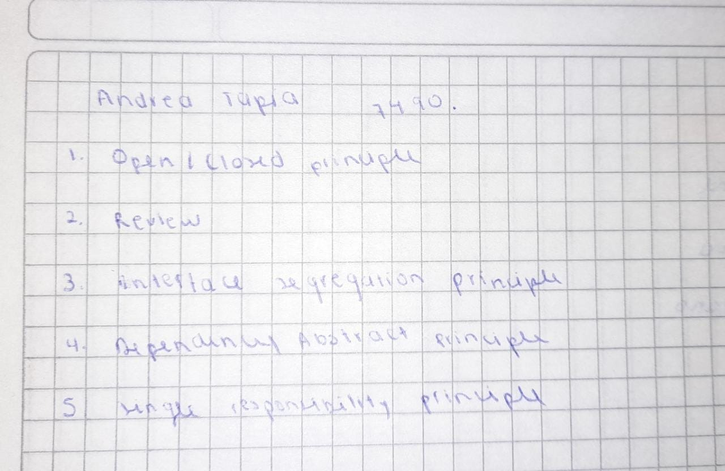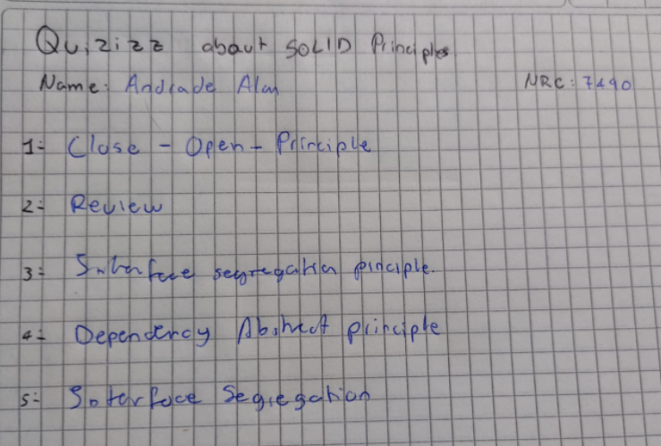

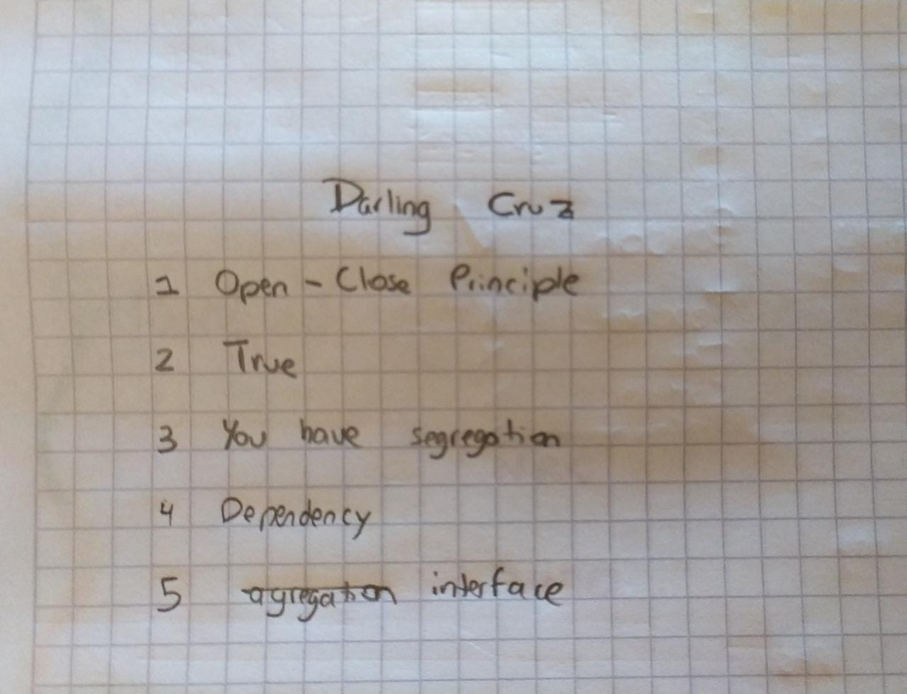

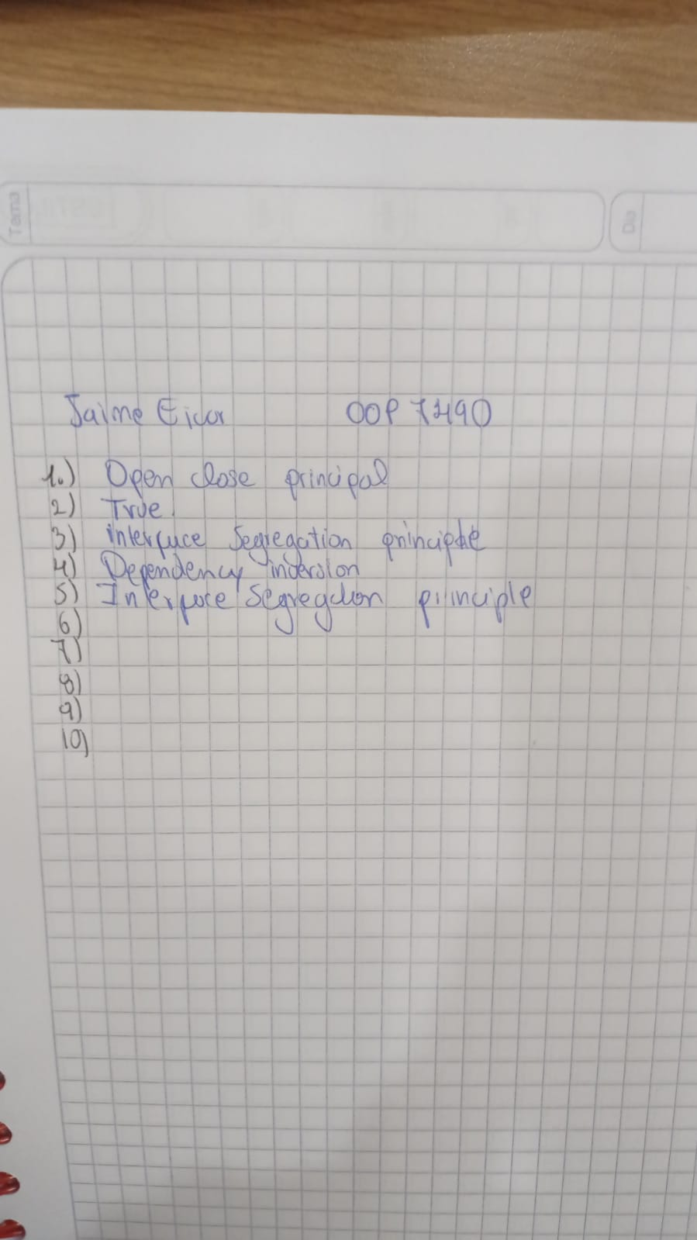

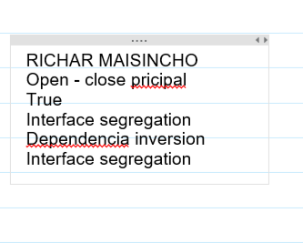

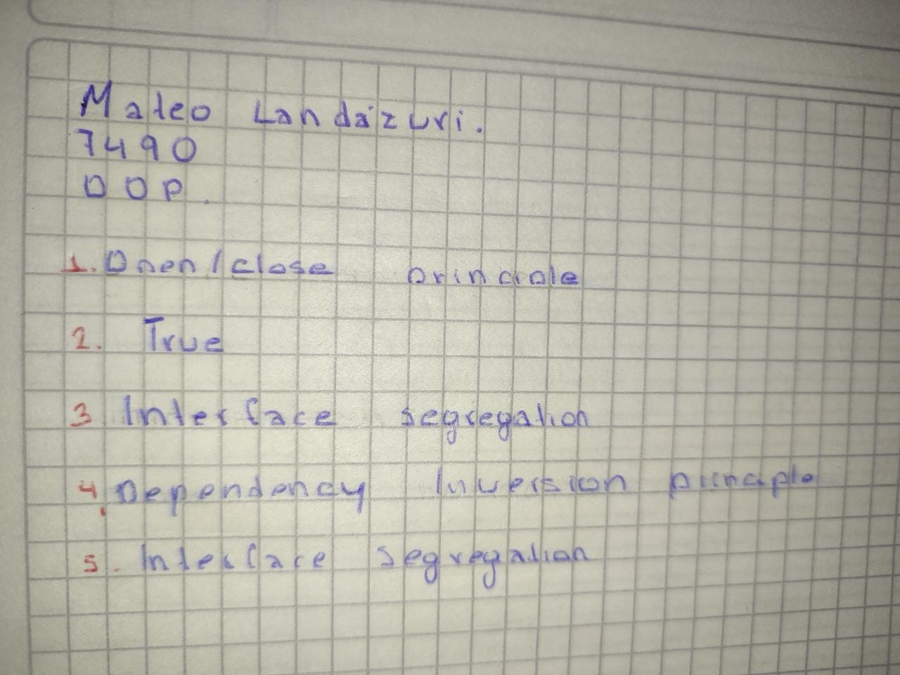

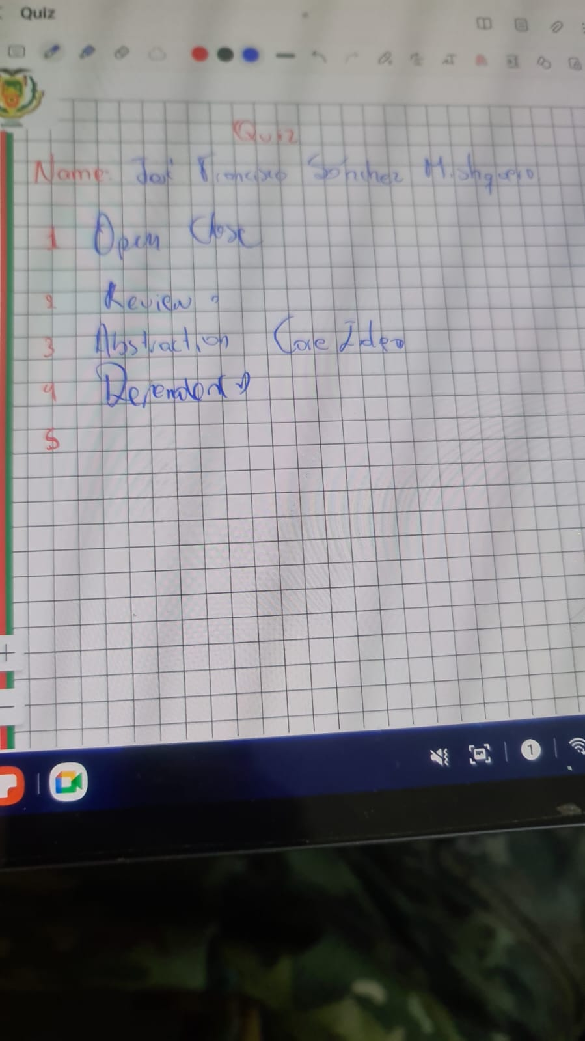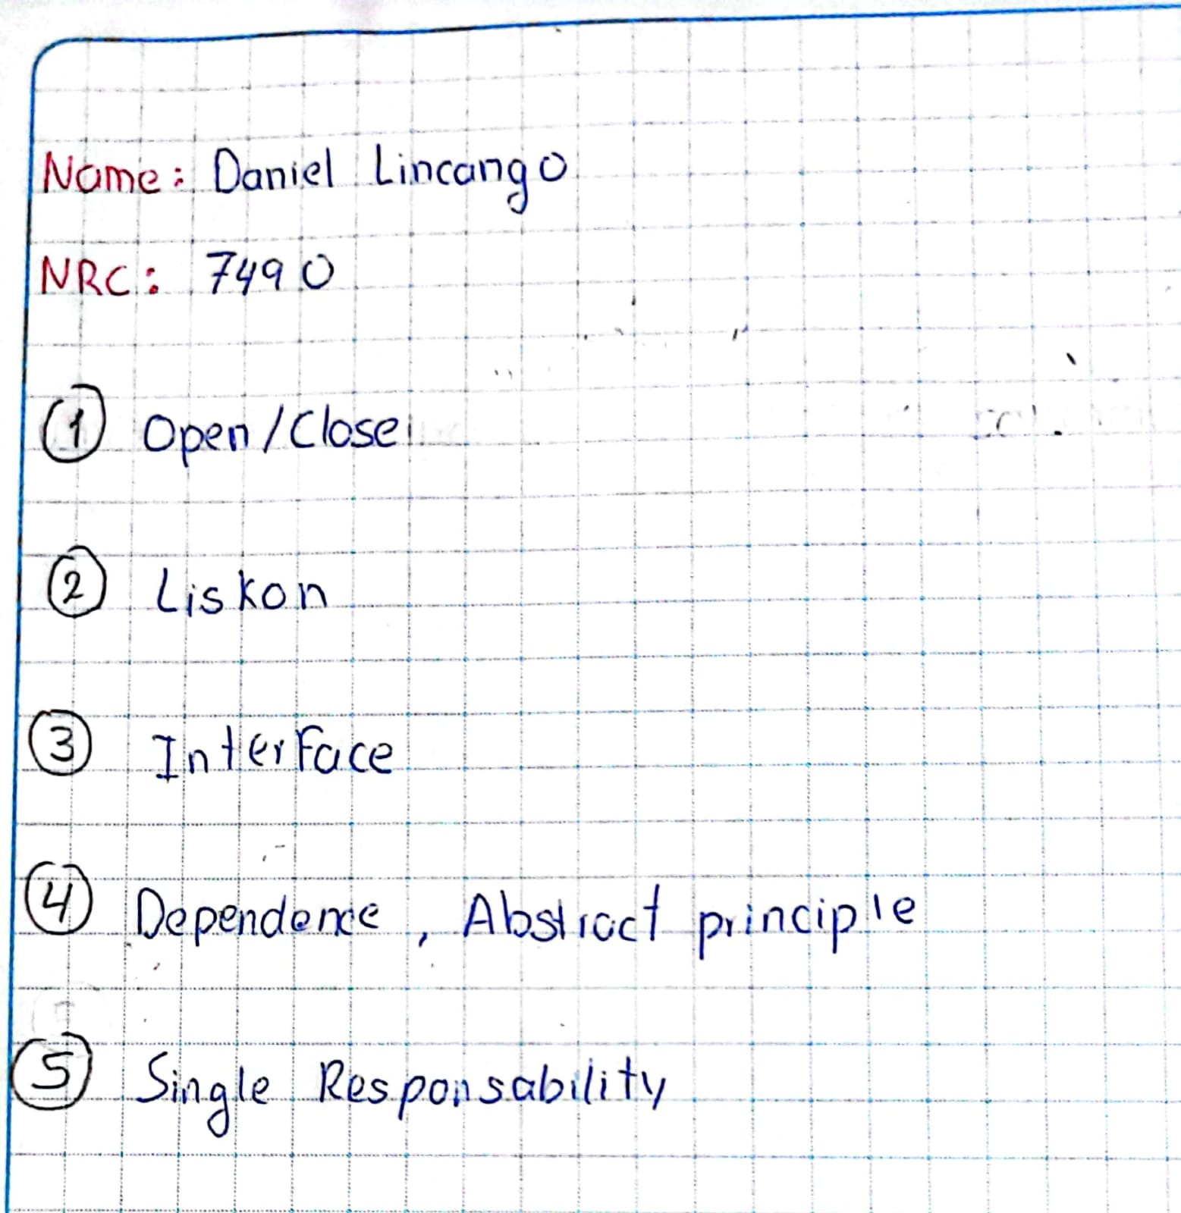

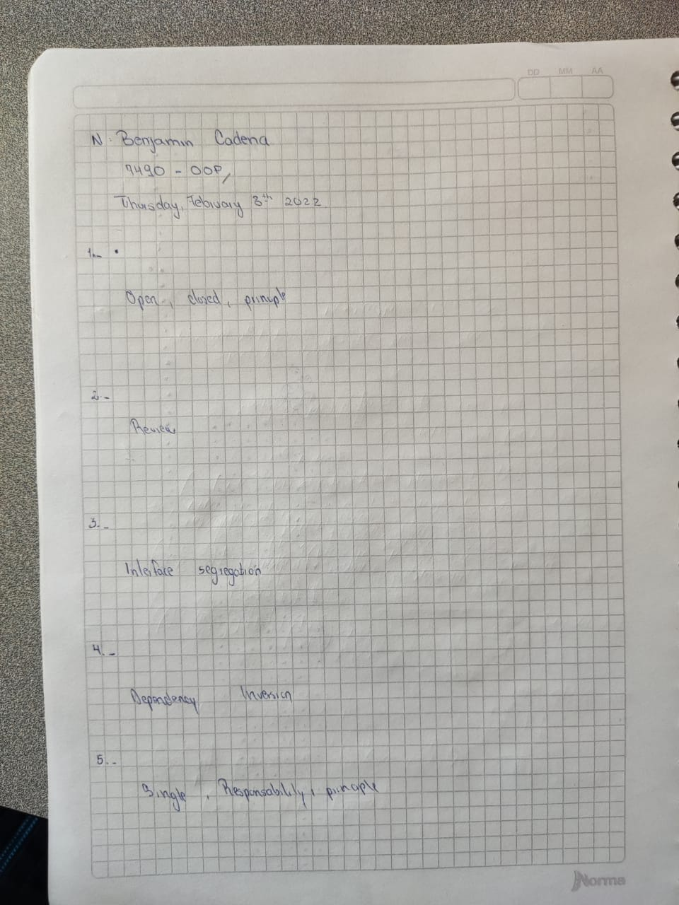

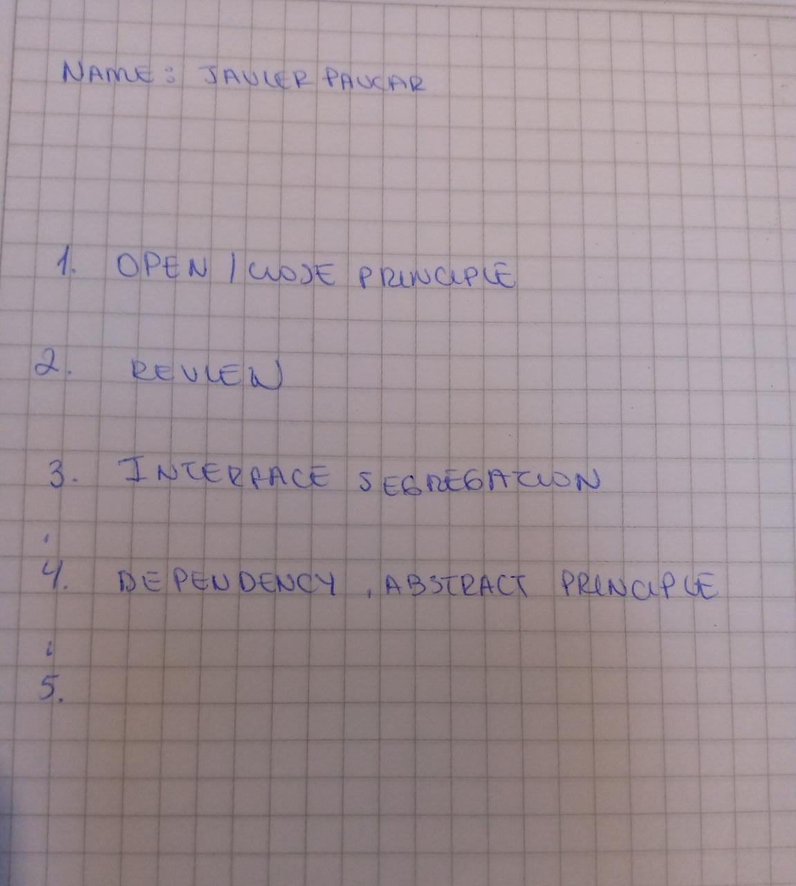

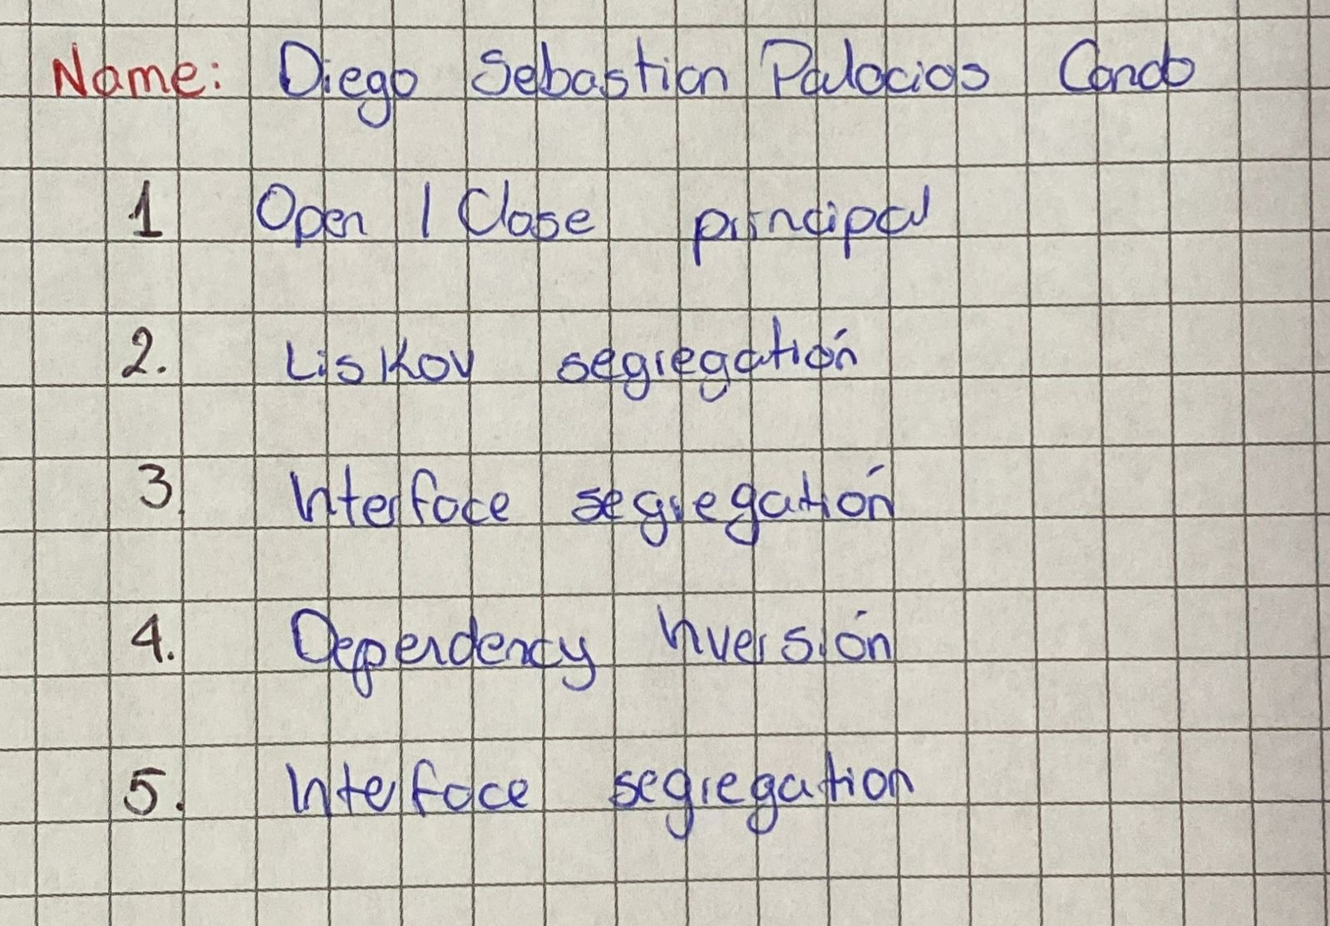

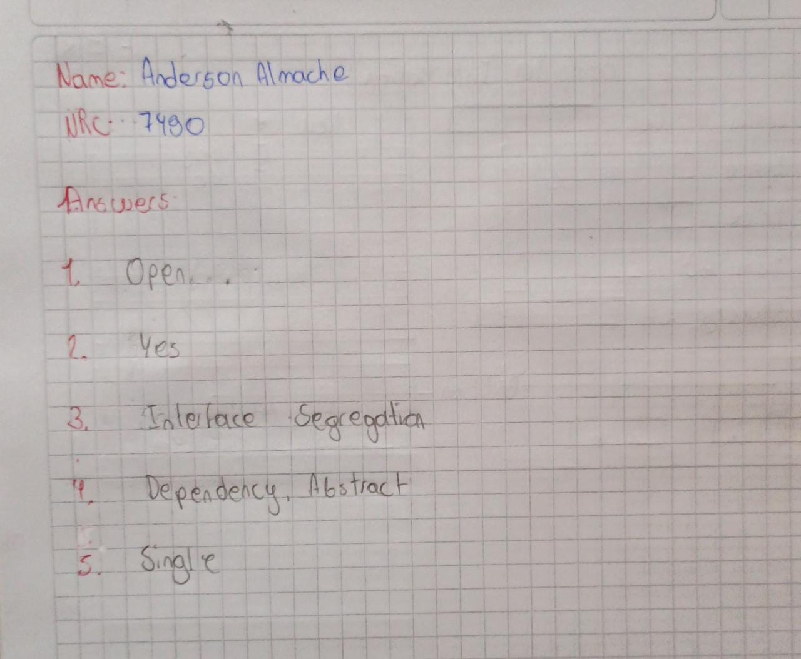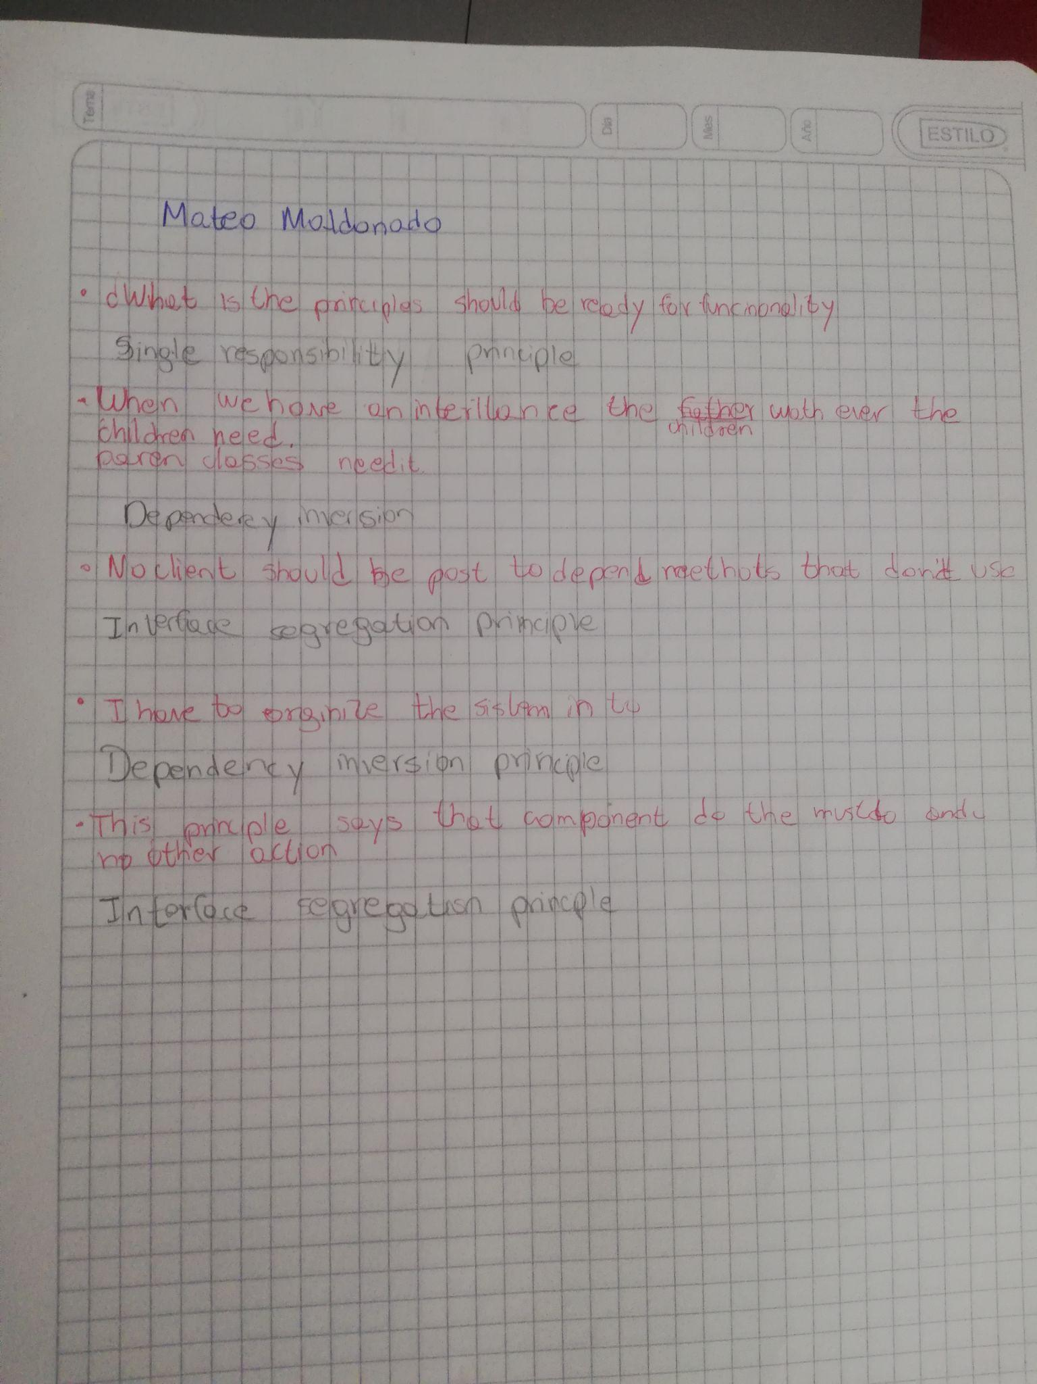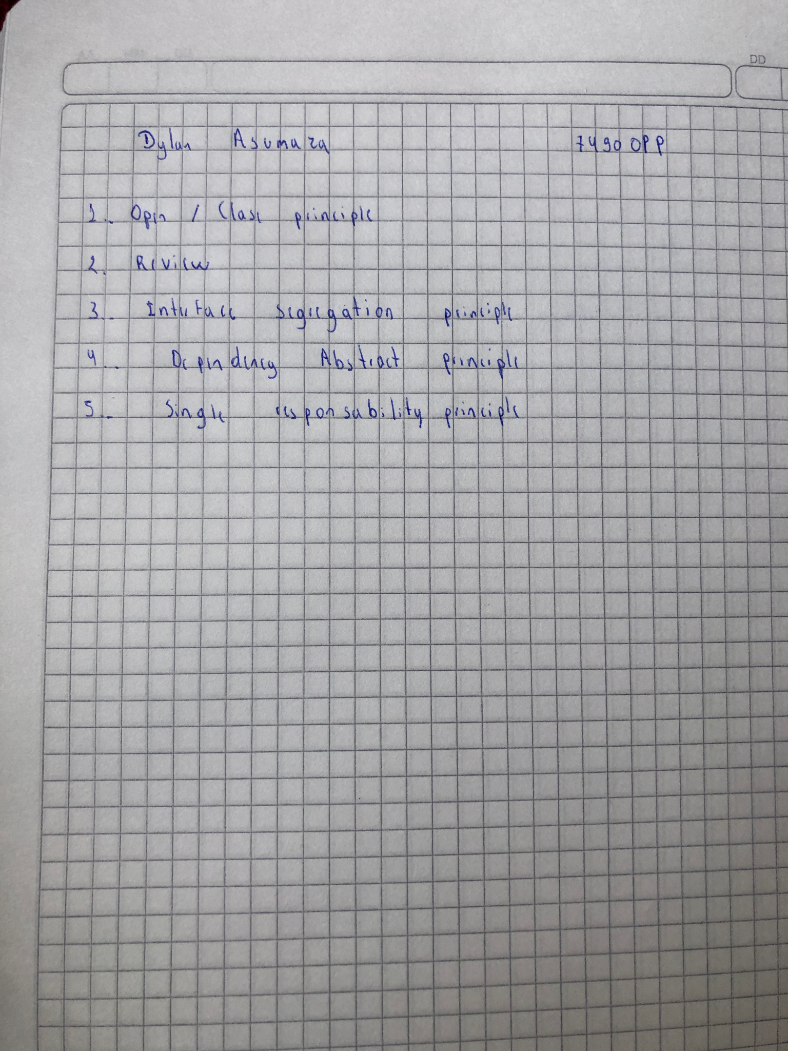

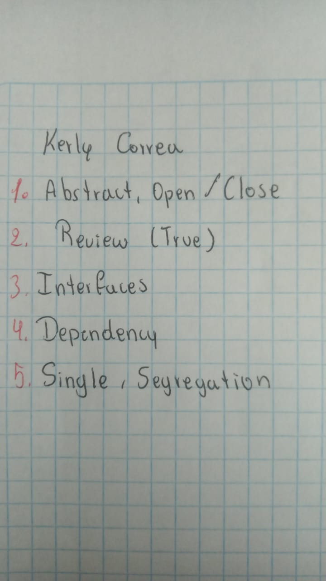

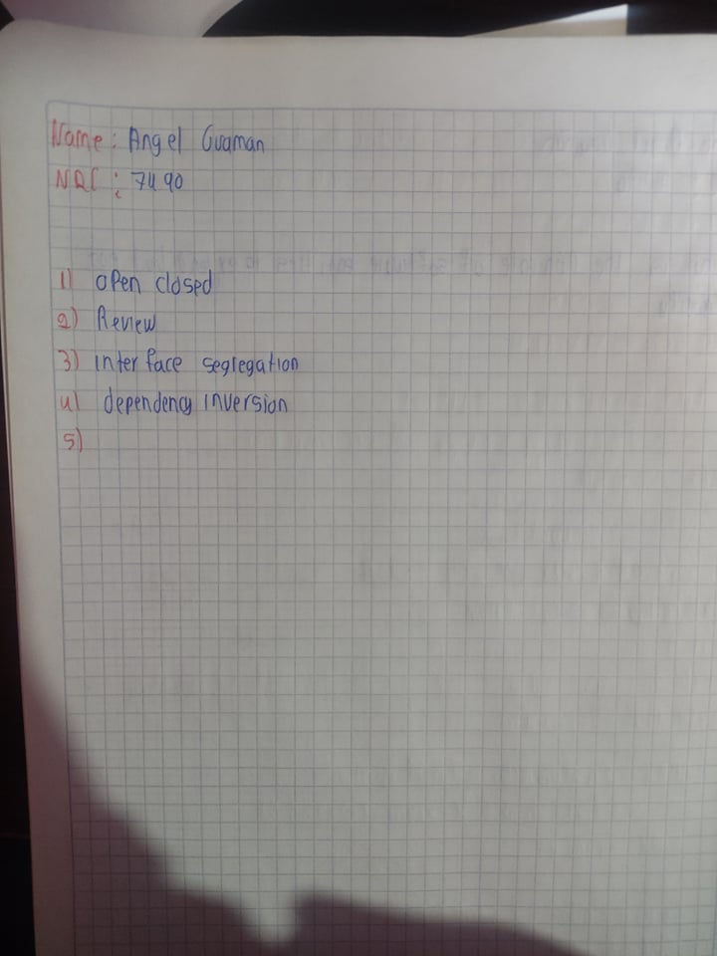

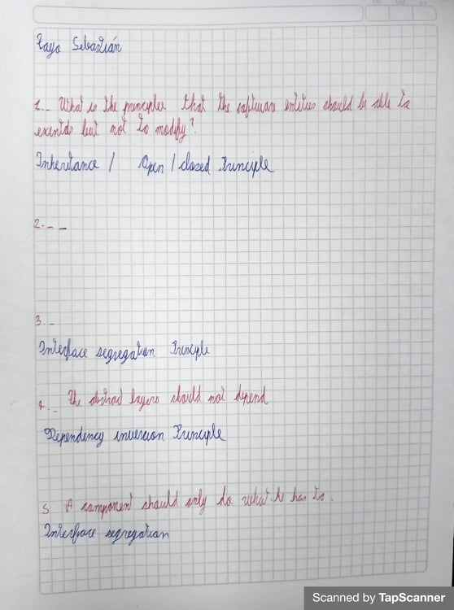

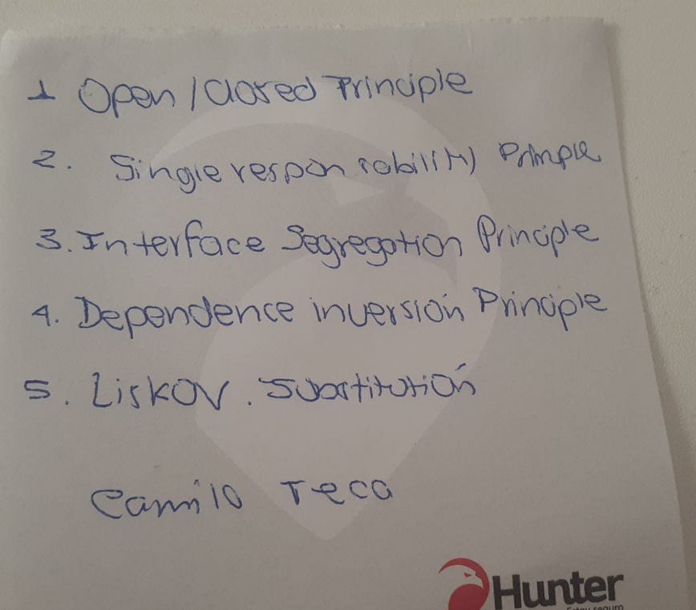

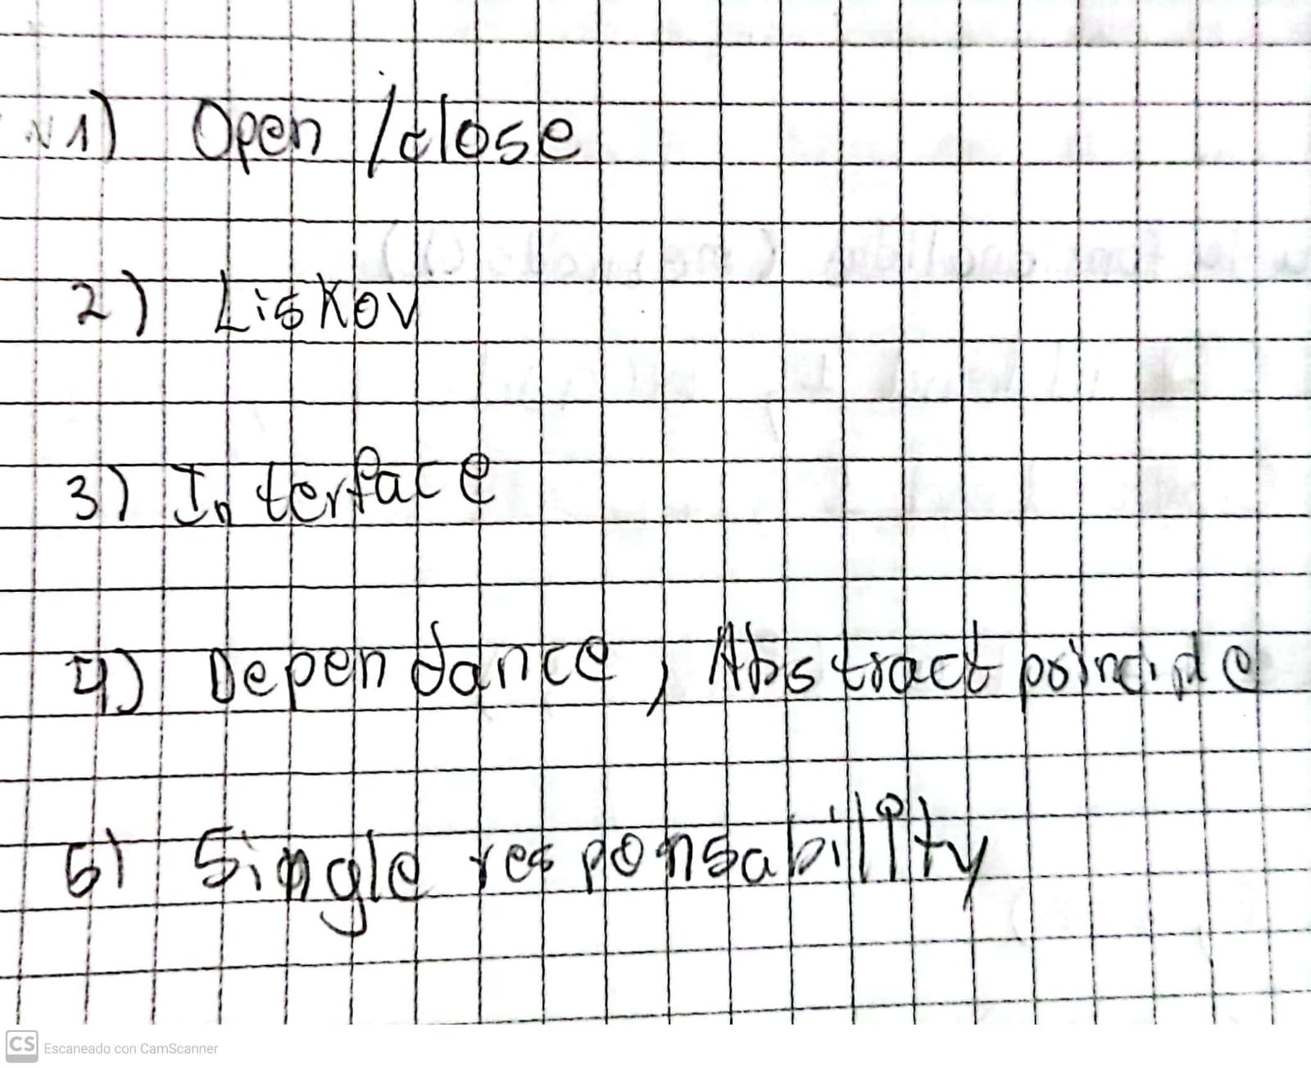Alexander Ruano

